**BDS Assignment 1**

**Submitted by : Group no : 95**

**Hrudhay Kolli - 2019AH04040**

**Narendrababu S - 2019AH04022**

**Akshat Gupta - 2019AH04001**

**---> We used Google Cloud Platform(GCP) to work on this assignment.**

**Complete Approach:**

1. First Uploaded all months Yellow and Green Taxi CSV on Hadoop Server using the following commands:

curl -L https://s3.amazonaws.com/nyc-tlc/trip+data/yellow_tripdata_2019-01.csv | gsutil cp - gs://bds_assignment_1/data/raw/trip-data-yellow/yellow_tripdata_2019-01.csv

curl -L https://s3.amazonaws.com/nyc-tlc/trip+data/green_tripdata_2019-01.csv | gsutil cp - gs://bds_assignment_1/data/raw/trip-data-green/green_tripdata_2019-01.csv

curl -L https://s3.amazonaws.com/nyc-tlc/trip+data/yellow_tripdata_2019-02.csv | gsutil cp - gs://bds_assignment_1/data/raw/trip-data-yellow/yellow_tripdata_2019-02.csv

curl -L https://s3.amazonaws.com/nyc-tlc/trip+data/green_tripdata_2019-02.csv | gsutil cp - gs://bds_assignment_1/data/raw/trip-data-green/green_tripdata_2019-02.csv

curl -L https://s3.amazonaws.com/nyc-tlc/trip+data/yellow_tripdata_2019-03.csv | gsutil cp - gs://bds_assignment_1/data/raw/trip-data-yellow/yellow_tripdata_2019-03.csv

curl -L https://s3.amazonaws.com/nyc-tlc/trip+data/green_tripdata_2019-03.csv | gsutil cp - gs://bds_assignment_1/data/raw/trip-data-green/green_tripdata_2019-03.csv

curl -L https://s3.amazonaws.com/nyc-tlc/trip+data/yellow_tripdata_2019-04.csv | gsutil cp - gs://bds_assignment_1/data/raw/trip-data-yellow/yellow_tripdata_2019-04.csv

curl -L https://s3.amazonaws.com/nyc-tlc/trip+data/green_tripdata_2019-04.csv | gsutil cp - gs://bds_assignment_1/data/raw/trip-data-green/green_tripdata_2019-04.csv

curl -L https://s3.amazonaws.com/nyc-tlc/trip+data/yellow_tripdata_2019-05.csv | gsutil cp - gs://bds_assignment_1/data/raw/trip-data-yellow/yellow_tripdata_2019-05.csv

curl -L https://s3.amazonaws.com/nyc-tlc/trip+data/green_tripdata_2019-05.csv | gsutil cp - gs://bds_assignment_1/data/raw/trip-data-green/green_tripdata_2019-05.csv

curl -L https://s3.amazonaws.com/nyc-tlc/trip+data/yellow_tripdata_2019-06.csv | gsutil cp - gs://bds_assignment_1/data/raw/trip-data-yellow/yellow_tripdata_2019-06.csv

curl -L https://s3.amazonaws.com/nyc-tlc/trip+data/green_tripdata_2019-06.csv | gsutil cp - gs://bds_assignment_1/data/raw/trip-data-green/green_tripdata_2019-06.csv

curl -L https://s3.amazonaws.com/nyc-tlc/trip+data/yellow_tripdata_2019-07.csv | gsutil cp - gs://bds_assignment_1/data/raw/trip-data-yellow/yellow_tripdata_2019-07.csv

curl -L https://s3.amazonaws.com/nyc-tlc/trip+data/green_tripdata_2019-07.csv | gsutil cp - gs://bds_assignment_1/data/raw/trip-data-green/green_tripdata_2019-07.csv

curl -L https://s3.amazonaws.com/nyc-tlc/trip+data/yellow_tripdata_2019-08.csv | gsutil cp - gs://bds_assignment_1/data/raw/trip-data-yellow/yellow_tripdata_2019-08.csv

curl -L https://s3.amazonaws.com/nyc-tlc/trip+data/green_tripdata_2019-08.csv | gsutil cp - gs://bds_assignment_1/data/raw/trip-data-green/green_tripdata_2019-08.csv

curl -L https://s3.amazonaws.com/nyc-tlc/trip+data/yellow_tripdata_2019-09.csv | gsutil cp - gs://bds_assignment_1/data/raw/trip-data-yellow/yellow_tripdata_2019-09.csv

curl -L https://s3.amazonaws.com/nyc-tlc/trip+data/green_tripdata_2019-09.csv | gsutil cp - gs://bds_assignment_1/data/raw/trip-data-green/green_tripdata_2019-09.csv

curl -L https://s3.amazonaws.com/nyc-tlc/trip+data/yellow_tripdata_2019-10.csv | gsutil cp - gs://bds_assignment_1/data/raw/trip-data-yellow/yellow_tripdata_2019-10.csv

curl -L https://s3.amazonaws.com/nyc-tlc/trip+data/green_tripdata_2019-10.csv | gsutil cp - gs://bds_assignment_1/data/raw/trip-data-green/green_tripdata_2019-10.csv

curl -L https://s3.amazonaws.com/nyc-tlc/trip+data/yellow_tripdata_2019-11.csv | gsutil cp - gs://bds_assignment_1/data/raw/trip-data-yellow/yellow_tripdata_2019-11.csv

curl -L https://s3.amazonaws.com/nyc-tlc/trip+data/green_tripdata_2019-11.csv | gsutil cp - gs://bds_assignment_1/data/raw/trip-data-green/green_tripdata_2019-11.csv

curl -L https://s3.amazonaws.com/nyc-tlc/trip+data/yellow_tripdata_2019-12.csv | gsutil cp - gs://bds_assignment_1/data/raw/trip-data-yellow/yellow_tripdata_2019-12.csv

curl -L https://s3.amazonaws.com/nyc-tlc/trip+data/green_tripdata_2019-12.csv | gsutil cp - gs://bds_assignment_1/data/raw/trip-data-green/green_tripdata_2019-12.csv

1. Connect to HIVE using the following command:

beeline -u jdbc:hive2://localhost:10000/default -n iron2rocks@cluster-a0f2-m -d org.apache.hive.jdbc.HiveDriver

1. Created schema in HIVE using the following command:

CREATE SCHEMA IF NOT EXISTS group95;

1. Created Two Tables in Hive in my schema ‘group95’. Tables name **group95.yellow_taxi** and **group95.green_taxi** using the following commands**:**

CREATE TABLE IF NOT EXISTS group95.yellow_taxi

(

vendorid INT,

tpep_pickup_timestamp STRING,

tpep_dropoff_timestamp STRING,

passenger_count INT,

trip_distance DOUBLE,

rate_code_id INT,

store_forward_flag STRING,

pickup_location_id INT,

dropoff_location_id INT,

payment_type INT,

fare_charge DOUBLE,

extra_charge DOUBLE,

mta_tax_charge DOUBLE,

tip_amount DOUBLE,

tolls_charge DOUBLE,

improvement_surcharge DOUBLE,

total_charge DOUBLE,

congestion_surcharge DOUBLE

) row format delimited fields TERMINATED BY ',' LINES TERMINATED BY '\n'

tblproperties ("skip.header.line.count"="1");

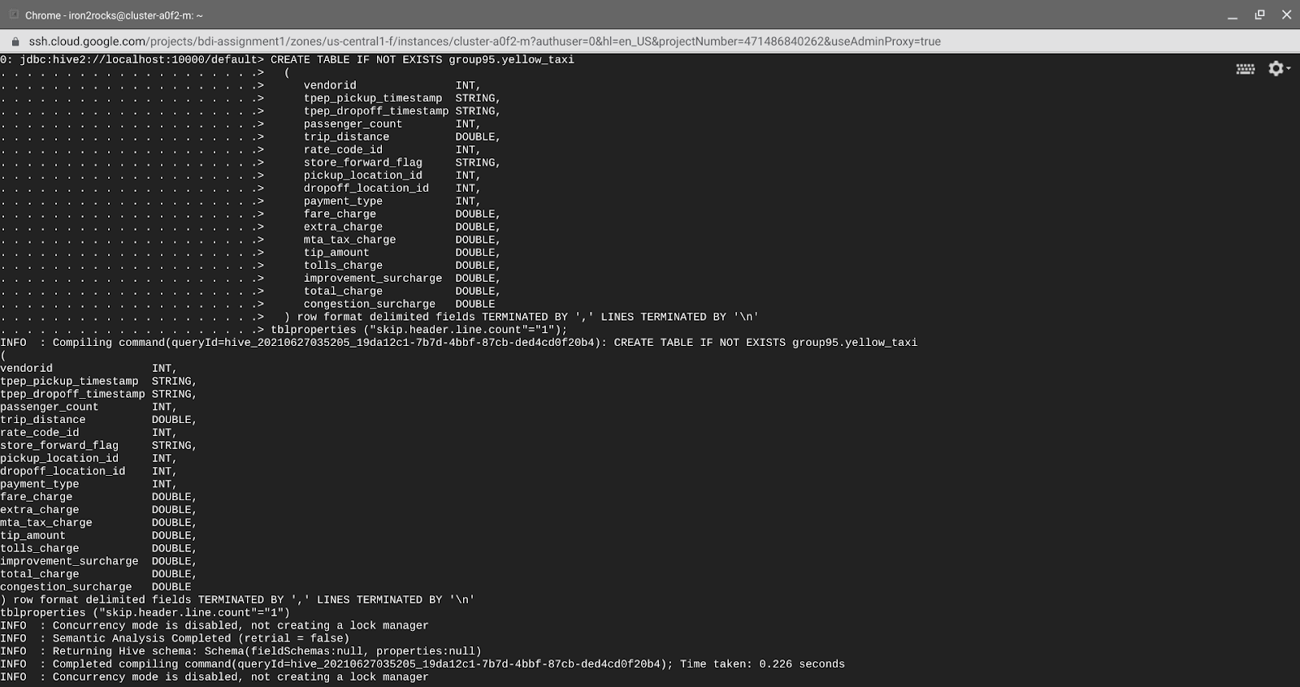

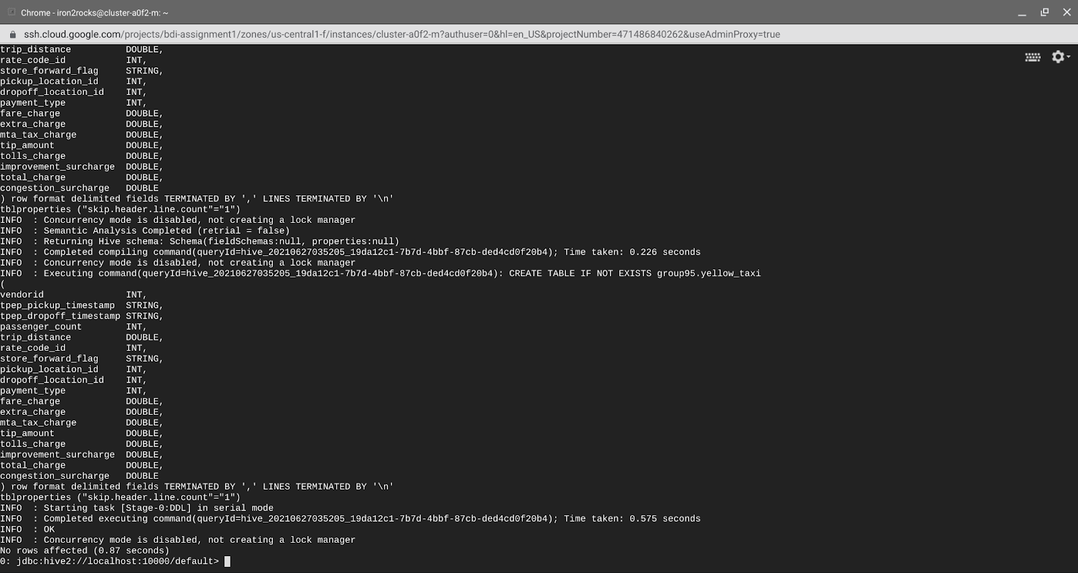

CREATE TABLE IF NOT EXISTS group95.green_taxi

(

vendorid INT,

lpep_pickup_timestamp STRING,

lpep_dropoff_timestamp STRING,

store_forward_flag STRING,

rate_code_id INT,

pickup_location_id INT,

dropoff_location_id INT,

passenger_count INT,

trip_distance DOUBLE,

fare_charge DOUBLE,

extra_charge DOUBLE,

mta_tax_charge DOUBLE,

tip_amount DOUBLE,

tolls_charge DOUBLE,

ehail_fee DOUBLE,

improvement_surcharge DOUBLE,

total_amount DOUBLE,

payment_type INT,

trip_type INT,

congestion_surcharge DOUBLE

) row format delimited fields TERMINATED BY ',' LINES TERMINATED BY '\n'

tblproperties ("skip.header.line.count"="1");

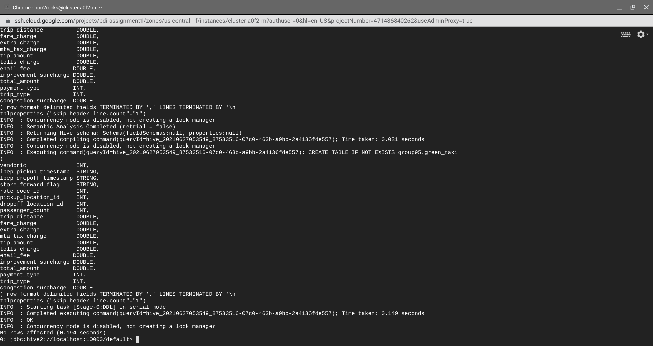

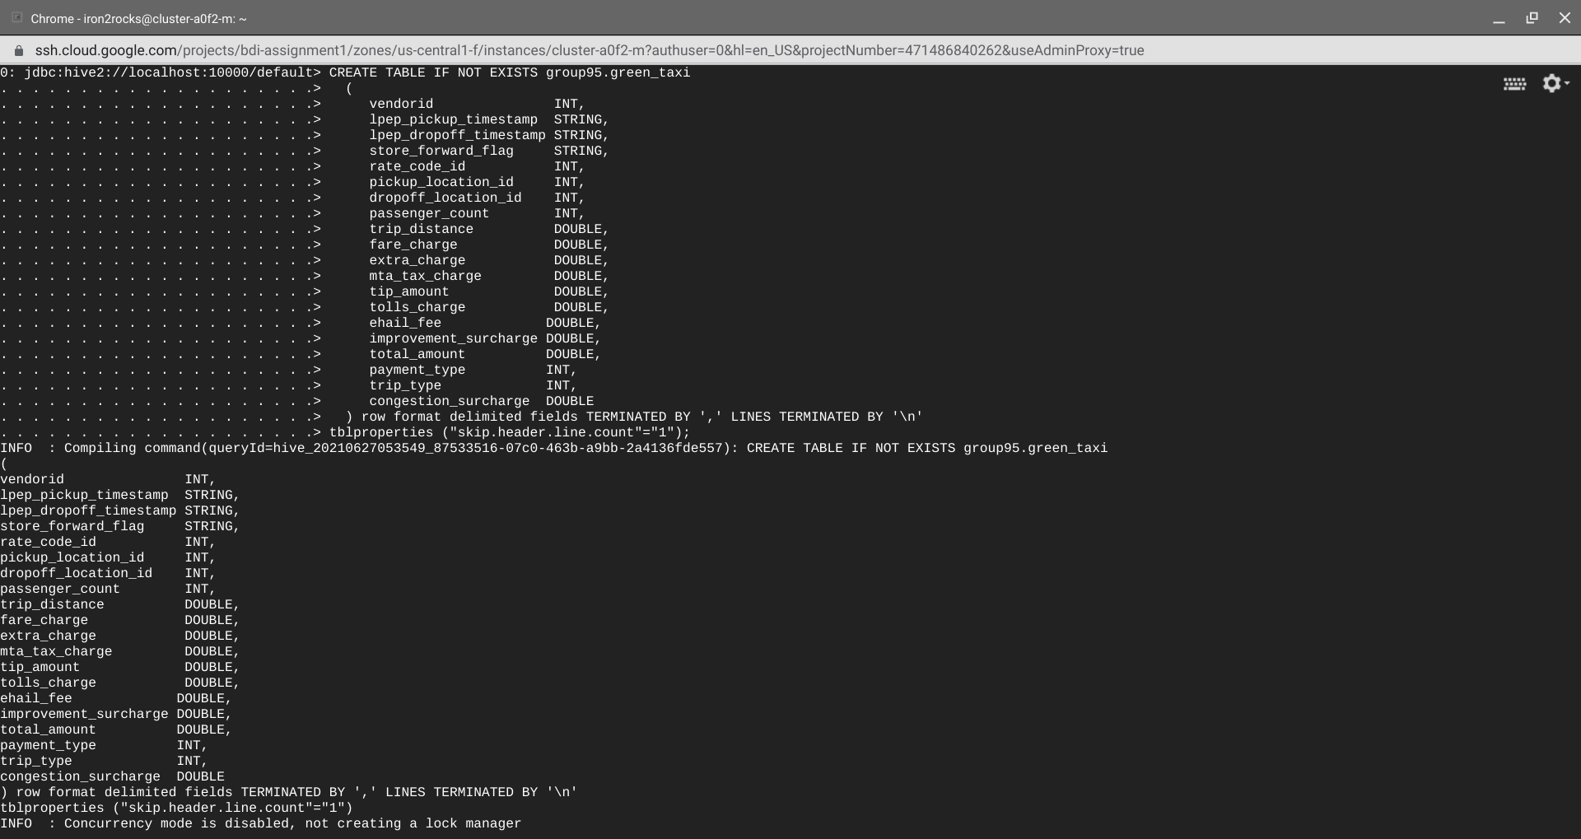

1. Use append load so all 12 months data comes in the same table using the following code:

load data inpath "gs://bds_assignment_1/data/raw/trip-data-yellow/yellow_tripdata_2019-01.csv" INTO TABLE group95.yellow_taxi;

load data inpath "gs://bds_assignment_1/data/raw/trip-data-yellow/yellow_tripdata_2019-02.csv" INTO TABLE group95.yellow_taxi;

load data inpath "gs://bds_assignment_1/data/raw/trip-data-yellow/yellow_tripdata_2019-03.csv" INTO TABLE group95.yellow_taxi;

load data inpath "gs://bds_assignment_1/data/raw/trip-data-yellow/yellow_tripdata_2019-04.csv" INTO TABLE group95.yellow_taxi;

load data inpath "gs://bds_assignment_1/data/raw/trip-data-yellow/yellow_tripdata_2019-05.csv" INTO TABLE group95.yellow_taxi;

load data inpath "gs://bds_assignment_1/data/raw/trip-data-yellow/yellow_tripdata_2019-06.csv" INTO TABLE group95.yellow_taxi;

load data inpath "gs://bds_assignment_1/data/raw/trip-data-yellow/yellow_tripdata_2019-07.csv" INTO TABLE group95.yellow_taxi;

load data inpath "gs://bds_assignment_1/data/raw/trip-data-yellow/yellow_tripdata_2019-08.csv" INTO TABLE group95.yellow_taxi;

load data inpath "gs://bds_assignment_1/data/raw/trip-data-yellow/yellow_tripdata_2019-09.csv" INTO TABLE group95.yellow_taxi;

load data inpath "gs://bds_assignment_1/data/raw/trip-data-yellow/yellow_tripdata_2019-10.csv" INTO TABLE group95.yellow_taxi;

load data inpath "gs://bds_assignment_1/data/raw/trip-data-yellow/yellow_tripdata_2019-11.csv" INTO TABLE group95.yellow_taxi;

load data inpath "gs://bds_assignment_1/data/raw/trip-data-yellow/yellow_tripdata_2019-12.csv" INTO TABLE group95.yellow_taxi;

load data inpath "gs://bds_assignment_1/data/raw/trip-data-green/green_tripdata_2019-01.csv" INTO TABLE group95.green_taxi;

load data inpath "gs://bds_assignment_1/data/raw/trip-data-green/green_tripdata_2019-02.csv" INTO TABLE group95.green_taxi;

load data inpath "gs://bds_assignment_1/data/raw/trip-data-green/green_tripdata_2019-03.csv" INTO TABLE group95.green_taxi;

load data inpath "gs://bds_assignment_1/data/raw/trip-data-green/green_tripdata_2019-04.csv" INTO TABLE group95.green_taxi;

load data inpath "gs://bds_assignment_1/data/raw/trip-data-green/green_tripdata_2019-05.csv" INTO TABLE group95.green_taxi;

load data inpath "gs://bds_assignment_1/data/raw/trip-data-green/green_tripdata_2019-06.csv" INTO TABLE group95.green_taxi;

load data inpath "gs://bds_assignment_1/data/raw/trip-data-green/green_tripdata_2019-07.csv" INTO TABLE group95.green_taxi;

load data inpath "gs://bds_assignment_1/data/raw/trip-data-green/green_tripdata_2019-08.csv" INTO TABLE group95.green_taxi;

load data inpath "gs://bds_assignment_1/data/raw/trip-data-green/green_tripdata_2019-09.csv" INTO TABLE group95.green_taxi;

load data inpath "gs://bds_assignment_1/data/raw/trip-data-green/green_tripdata_2019-10.csv" INTO TABLE group95.green_taxi;

load data inpath "gs://bds_assignment_1/data/raw/trip-data-green/green_tripdata_2019-11.csv" INTO TABLE group95.green_taxi;

load data inpath "gs://bds_assignment_1/data/raw/trip-data-green/green_tripdata_2019-12.csv" INTO TABLE group95.green_taxi;

1. Then started data Data preparation and Exploratory Data Analysis

**Data preparation and Exploratory Data Analysis**

1. **No. of Rows**

SELECT Count(*) FROM group95.yellow_taxi;  
→ 84399019 Rows

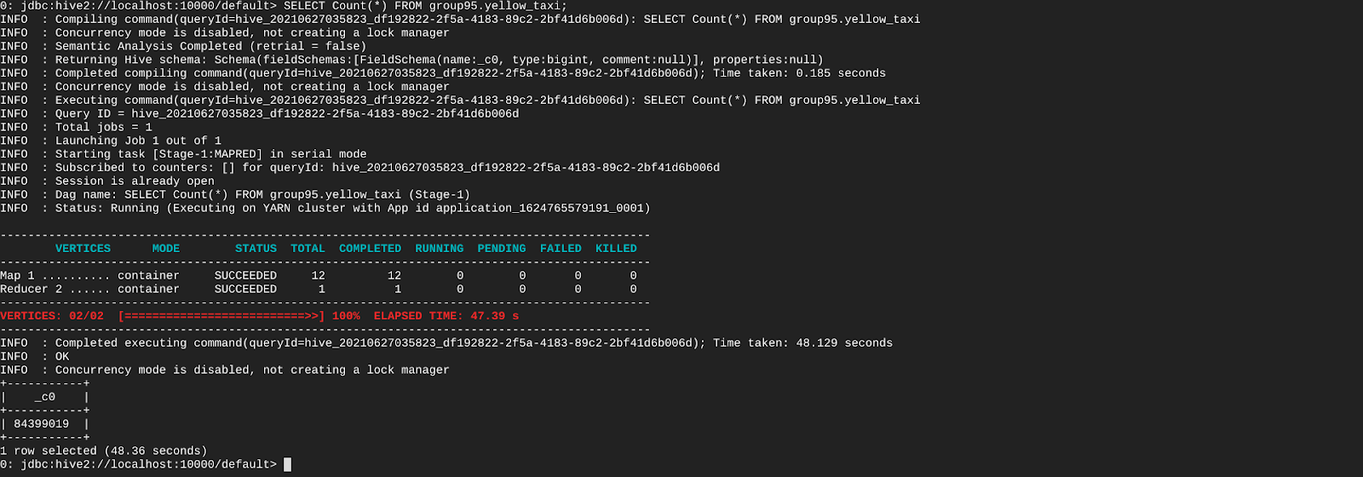

SELECT Count(*) FROM group95.green_taxi;

→ 6044050 Rows

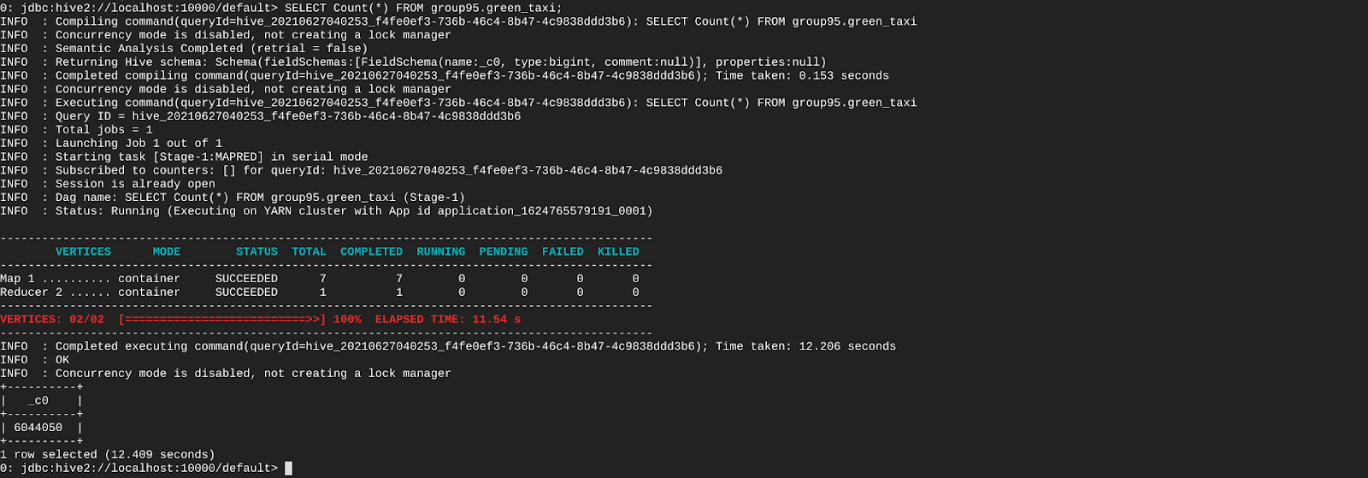

SELECT Count(vendorid),

Count(tpep_pickup_timestamp),

Count(tpep_dropoff_timestamp),

Count(passenger_count),

Count(trip_distance),

Count(rate_code_id),

Count(store_forward_flag),

Count(pickup_location_id),

Count(dropoff_location_id),

Count(payment_type),

Count(fare_charge),

Count(extra_charge),

Count(mta_tax_charge),

Count(tip_amount),

Count(tolls_charge),

Count(improvement_surcharge),

Count(total_charge)

FROM group95.yellow_taxi;

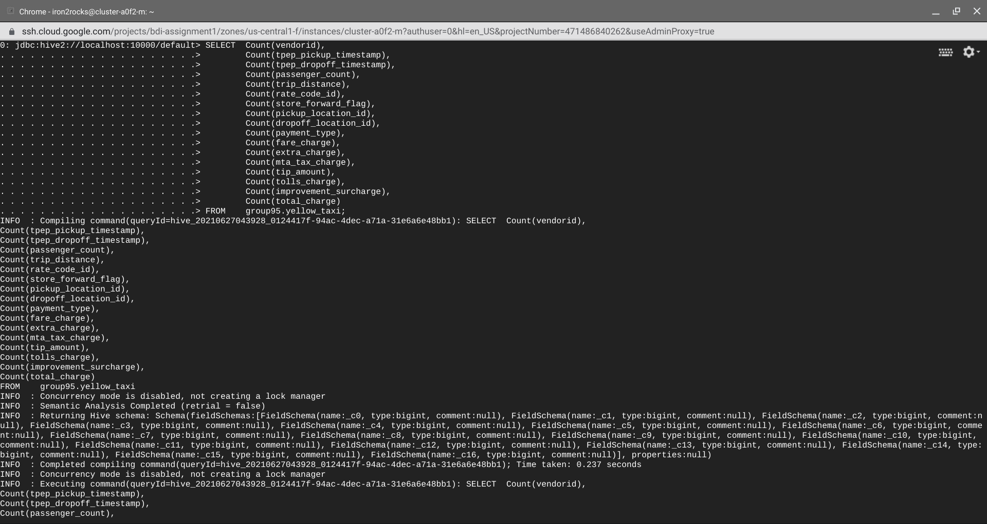

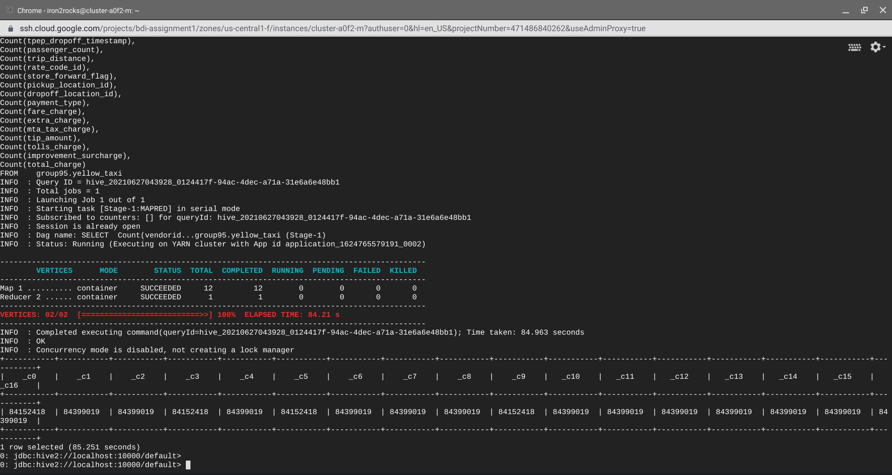

SELECT Count(vendorid),

Count(lpep_pickup_timestamp),

Count(lpep_dropoff_timestamp),

Count(passenger_count),

Count(trip_distance),

Count(rate_code_id),

Count(store_forward_flag),

Count(pickup_location_id),

Count(dropoff_location_id),

Count(payment_type),

Count(fare_charge),

Count(extra_charge),

Count(mta_tax_charge),

Count(tip_amount),

Count(tolls_charge),

Count(improvement_surcharge),

Count(total_charge)

FROM group95.green_taxi;

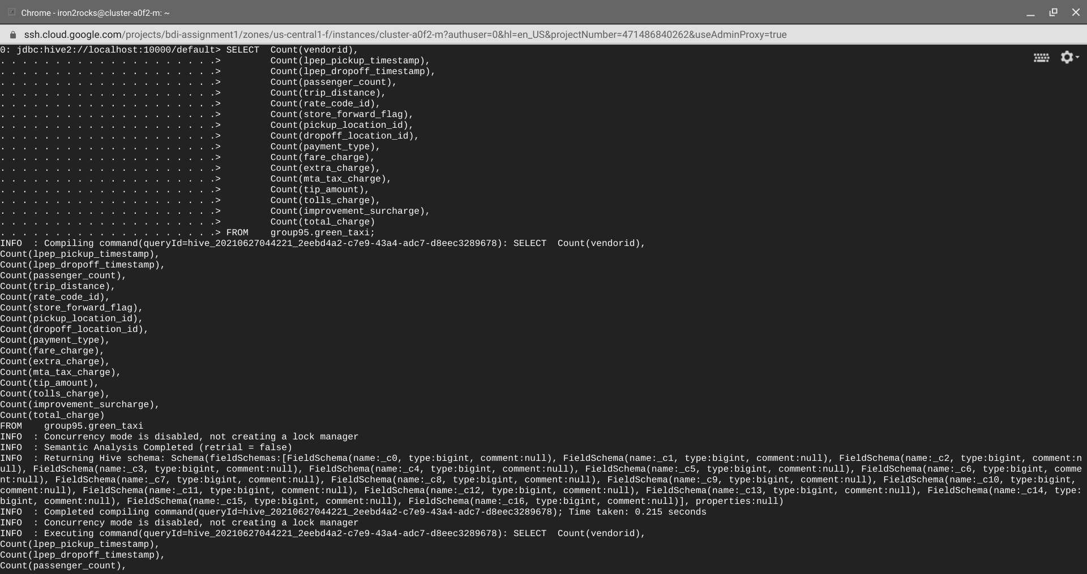

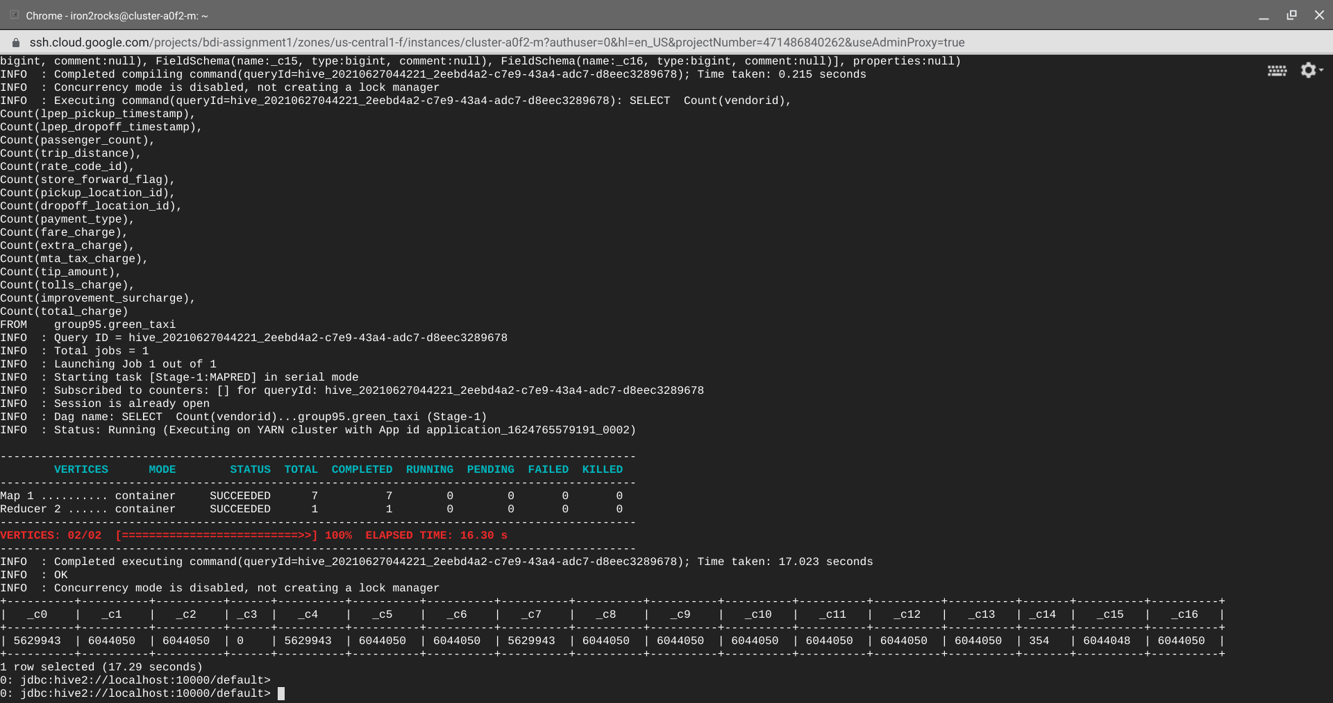

**Observation: Ideally all columns should have equal count but from the above outputs we observe that the counts are not equal for all columns in both the cases.**

1. **Populating all Values to get an outlook of complete data. This query helps to find min , max , distinct and average values of relevant field so has to find incorrect/inconsistent data and fix it.**

* **Dimension Data Check on both tables**

SELECT Count(*) AS number_of_records,

Count(DISTINCT vendorid) AS number_of_tpep_vendors,

Min(To_date(tpep_pickup_timestamp)) AS oldest_pickup_timestamp,

Max(To_date(tpep_pickup_timestamp)) AS recent_pickup_timestamp,

Min(To_date(tpep_dropoff_timestamp)) AS oldest_dropoff_timestamp,

Max(To_date(tpep_dropoff_timestamp)) AS recent_dropoff_timestamp,

Min(passenger_count) AS min_passengers_pertrip,

Max(passenger_count) AS max_passengers_pertrip,

Avg(passenger_count) AS average_passengers_pertrip,

Min(trip_distance) AS min_trip_distance,

Max(trip_distance) AS max_trip_distance,

Avg(trip_distance) AS average_trip_distance,

Count(DISTINCT store_forward_flag) AS types_of_Store_and_fwd_flag,

Count(DISTINCT pickup_location_id) AS num_of_pickup_zones,

Count(DISTINCT dropoff_location_id) AS num_of_dropoff_zones,

Count(DISTINCT payment_type) AS number_of_payment_types

FROM group95.yellow_taxi;

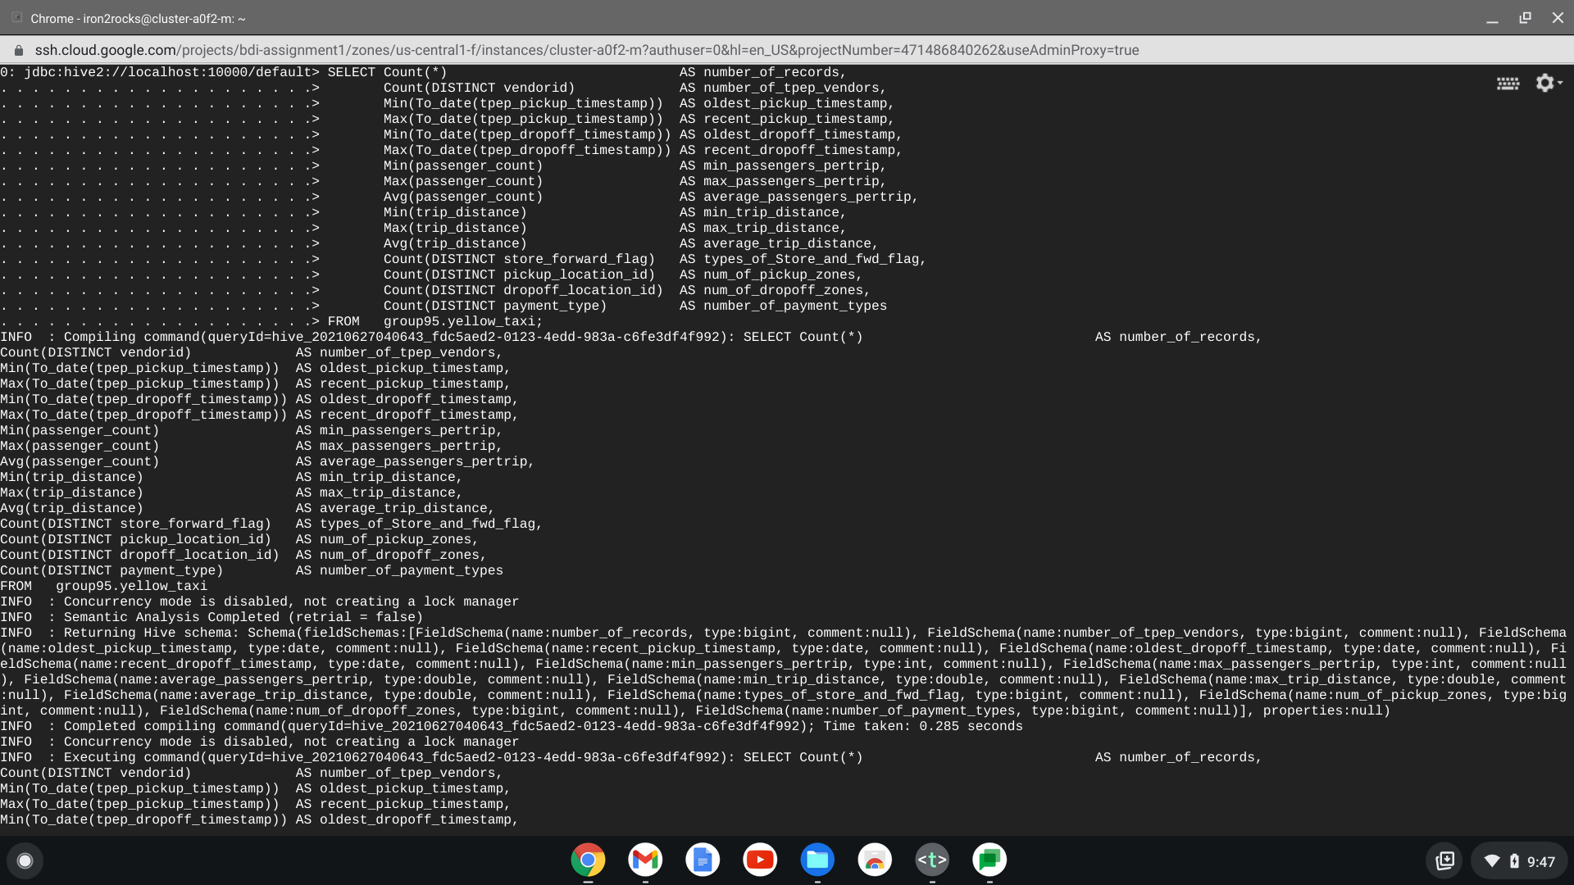

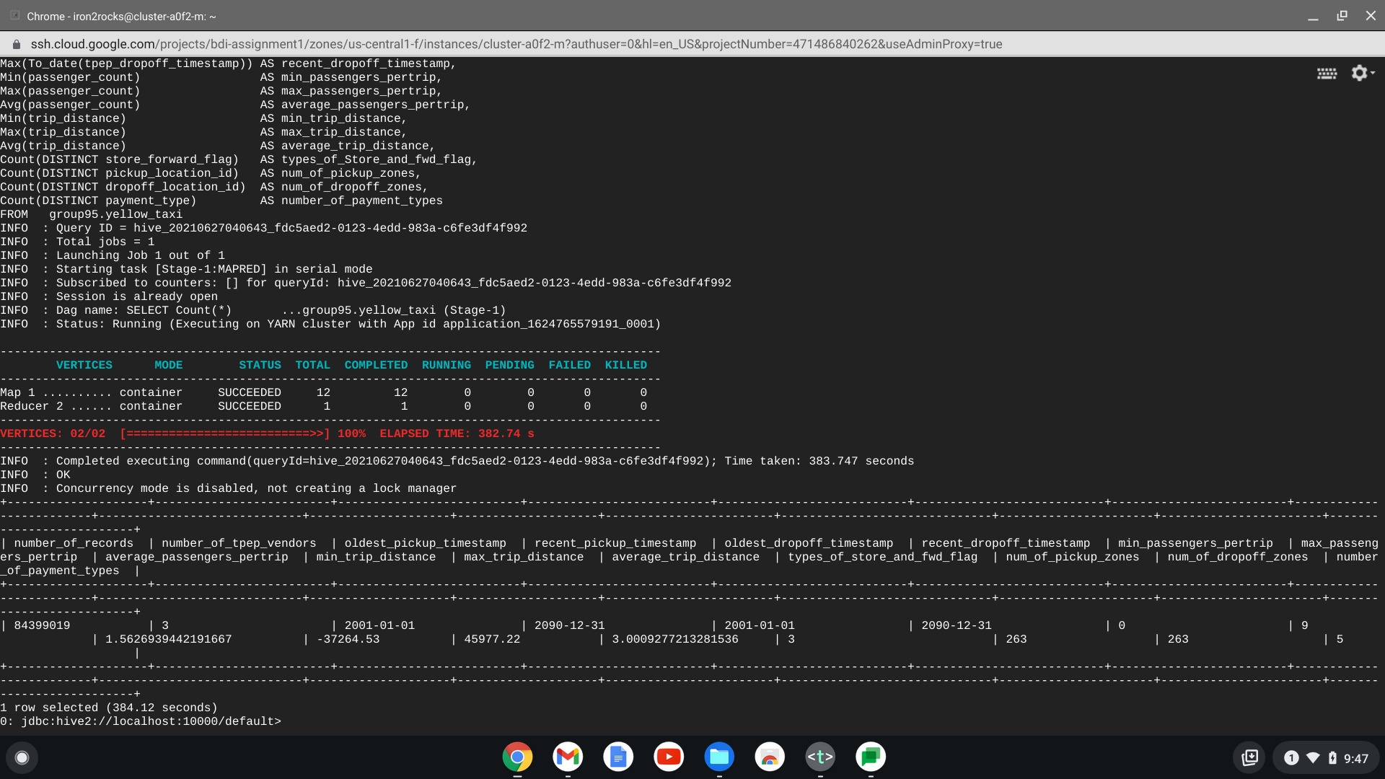

SELECT Count(*) AS number_of_records,

Count(DISTINCT vendorid) AS number_of_tpep_vendors,

Min(To_date(lpep_pickup_timestamp)) AS oldest_pickup_timestamp,

Max(To_date(lpep_pickup_timestamp)) AS recent_pickup_timestamp,

Min(To_date(lpep_dropoff_timestamp)) AS oldest_dropoff_timestamp,

Max(To_date(lpep_dropoff_timestamp)) AS recent_dropoff_timestamp,

Min(passenger_count) AS min_passengers_pertrip,

Max(passenger_count) AS max_passengers_pertrip,

Avg(passenger_count) AS average_passengers_pertrip,

Min(trip_distance) AS min_trip_distance,

Max(trip_distance) AS max_trip_distance,

Avg(trip_distance) AS average_trip_distance,

Count(DISTINCT store_forward_flag) AS types_of_Store_and_fwd_flag,

Count(DISTINCT pickup_location_id) AS num_of_pickup_zones,

Count(DISTINCT dropoff_location_id) AS num_of_dropoff_zones,

Count(DISTINCT payment_type) AS number_of_payment_types

FROM group95.green_taxi;

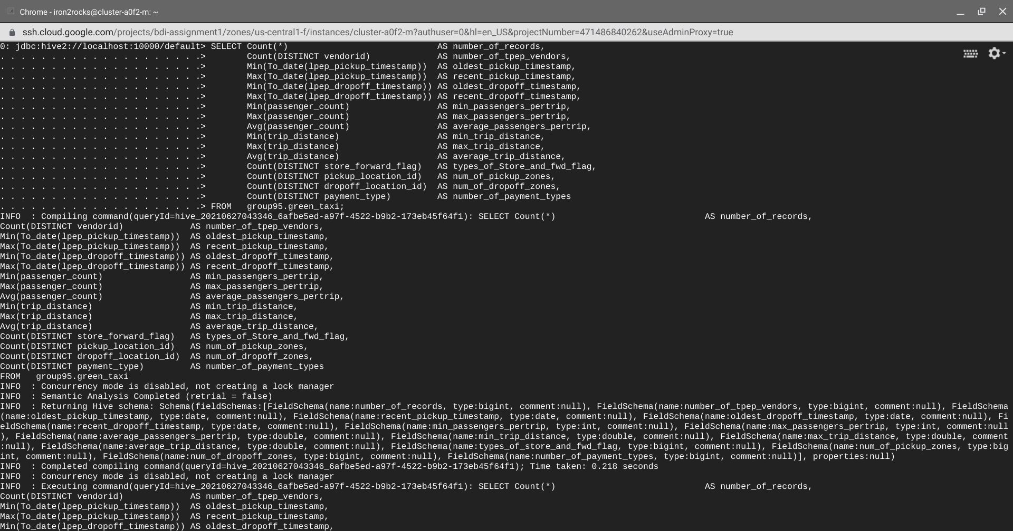

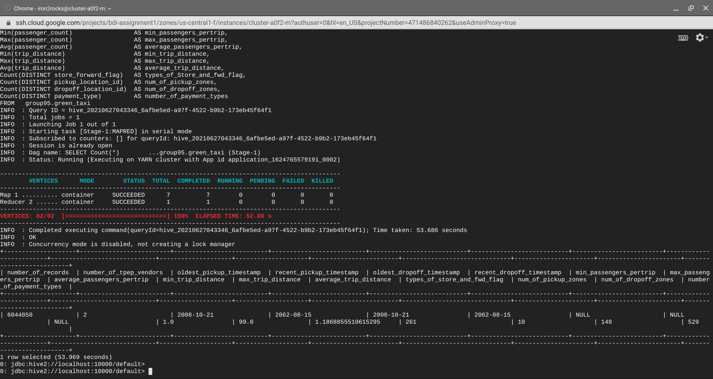

* **Fare Related Data Check on both tables**

SELECT Min(fare_charge) AS min_fare_charge,

Max(fare_charge) AS max_fare_charge,

Avg(fare_charge) AS average_fare_charge,

Min(extra_charge) AS min_extra_charge,

Max(extra_charge) AS max_extra_charge,

Avg(extra_charge) AS average_extra_charge,

Count(DISTINCT mta_tax_charge) AS types_of_mta_tax_charge,

Min(mta_tax_charge) AS min_mta_tax_charge,

Max(mta_tax_charge) AS max_mta_tax_charge,

Avg(mta_tax_charge) AS average_mta_tax_charge,

Min(tip_amount) AS min_tip_amount,

Max(tip_amount) AS max_tip_amount,

Avg(tip_amount) AS average_tip_amount,

Min(tolls_charge) AS min_toll_charge,

Max(tolls_charge) AS max_toll_charge,

Avg(tolls_charge) AS average_toll_charge,

Count(DISTINCT improvement_surcharge) AS types_of_surcharge,

Min(improvement_surcharge) AS min_surcharge,

Max(improvement_surcharge) AS max_surcharge,

Avg(improvement_surcharge) AS average_surcharge,

Min(total_charge) AS min_total_charge,

Max(total_charge) AS max_total_charge,

Avg(total_charge) AS average_total_charge

FROM group95.yellow_taxi;

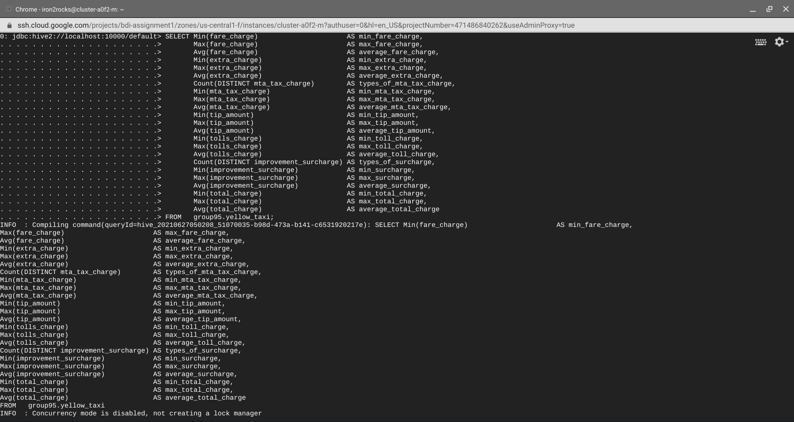

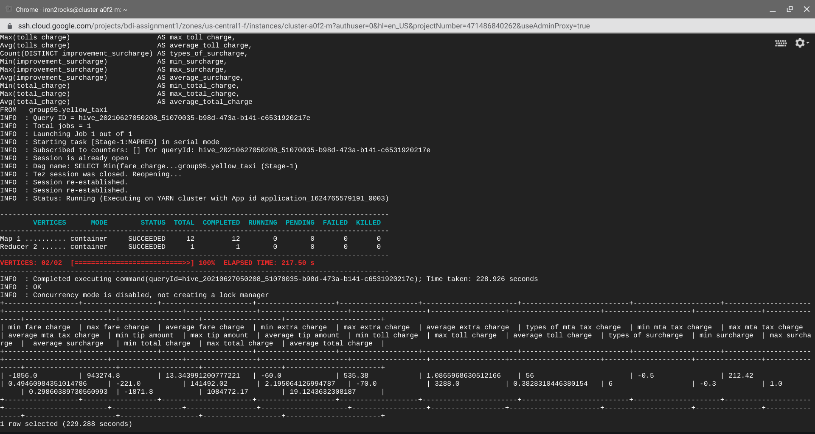

SELECT Min(fare_charge) AS min_fare_charge,

Max(fare_charge) AS max_fare_charge,

Avg(fare_charge) AS average_fare_charge,

Min(extra_charge) AS min_extra_charge,

Max(extra_charge) AS max_extra_charge,

Avg(extra_charge) AS average_extra_charge,

Count(DISTINCT mta_tax_charge) AS types_of_mta_tax_charge,

Min(mta_tax_charge) AS min_mta_tax_charge,

Max(mta_tax_charge) AS max_mta_tax_charge,

Avg(mta_tax_charge) AS average_mta_tax_charge,

Min(tip_amount) AS min_tip_amount,

Max(tip_amount) AS max_tip_amount,

Avg(tip_amount) AS average_tip_amount,

Min(tolls_charge) AS min_toll_charge,

Max(tolls_charge) AS max_toll_charge,

Avg(tolls_charge) AS average_toll_charge,

Count(DISTINCT improvement_surcharge) AS types_of_surcharge,

Min(improvement_surcharge) AS min_surcharge,

Max(improvement_surcharge) AS max_surcharge,

Avg(improvement_surcharge) AS average_surcharge,

Min(total_charge) AS min_total_charge,

Max(total_charge) AS max_total_charge,

Avg(total_charge) AS average_total_charge

FROM group95.green_taxi;

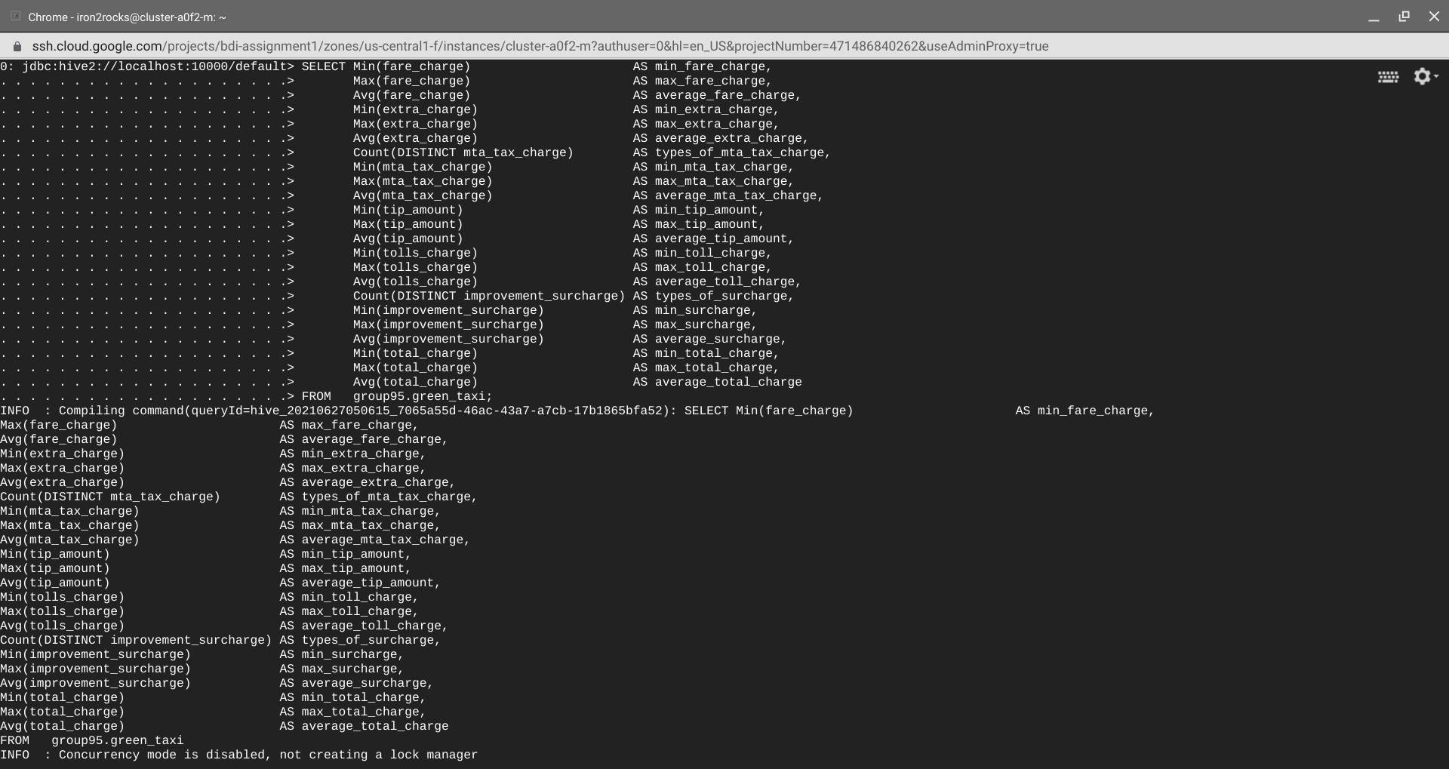

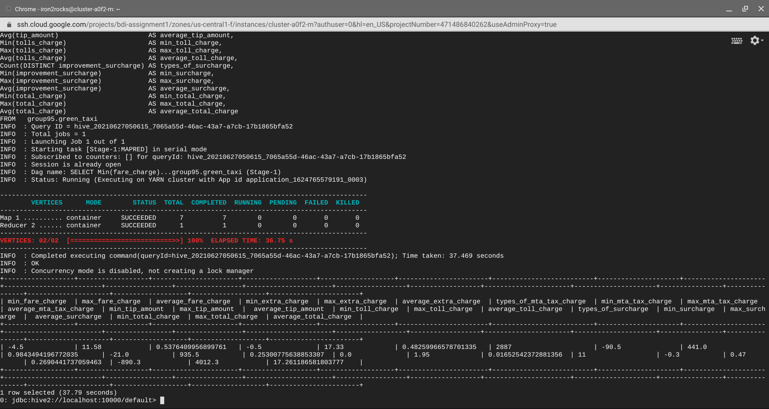

**Observation: From the above outputs, we can observe that there are negative values for charges, NULL value for passengers per trip data and negative values for trip distance.**

**These values have to be handled by removing them from the data to have clean, consistent and more reliable data.**

**Let us check for individual counts of these metrics/columns:**

* **Rate code:**

SELECT rate_code_id, Count(rate_code_id) FROM group95.yellow_taxi GROUP BY rate_code_id;

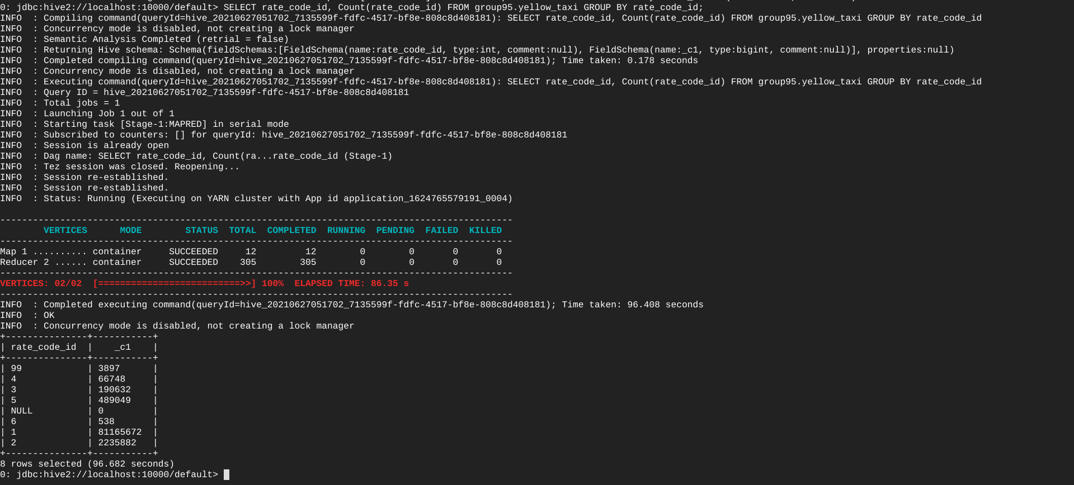

SELECT rate_code_id, Count(rate_code_id) FROM group95.green_taxi GROUP BY rate_code_id;

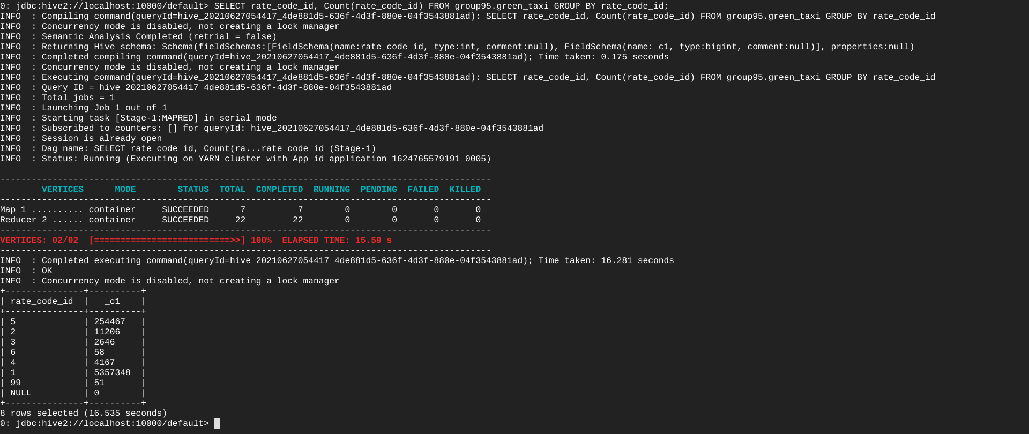

**Observation: As per the reference, rate code ids are values between 1-6 and in the above outputs we can see values for 99, NULL which shouldn’t be considered for our further analysis.**

* **Store forward flag:**

SELECT store_forward_flag, Count(store_forward_flag) FROM group95.yellow_taxi GROUP BY store_forward_flag;

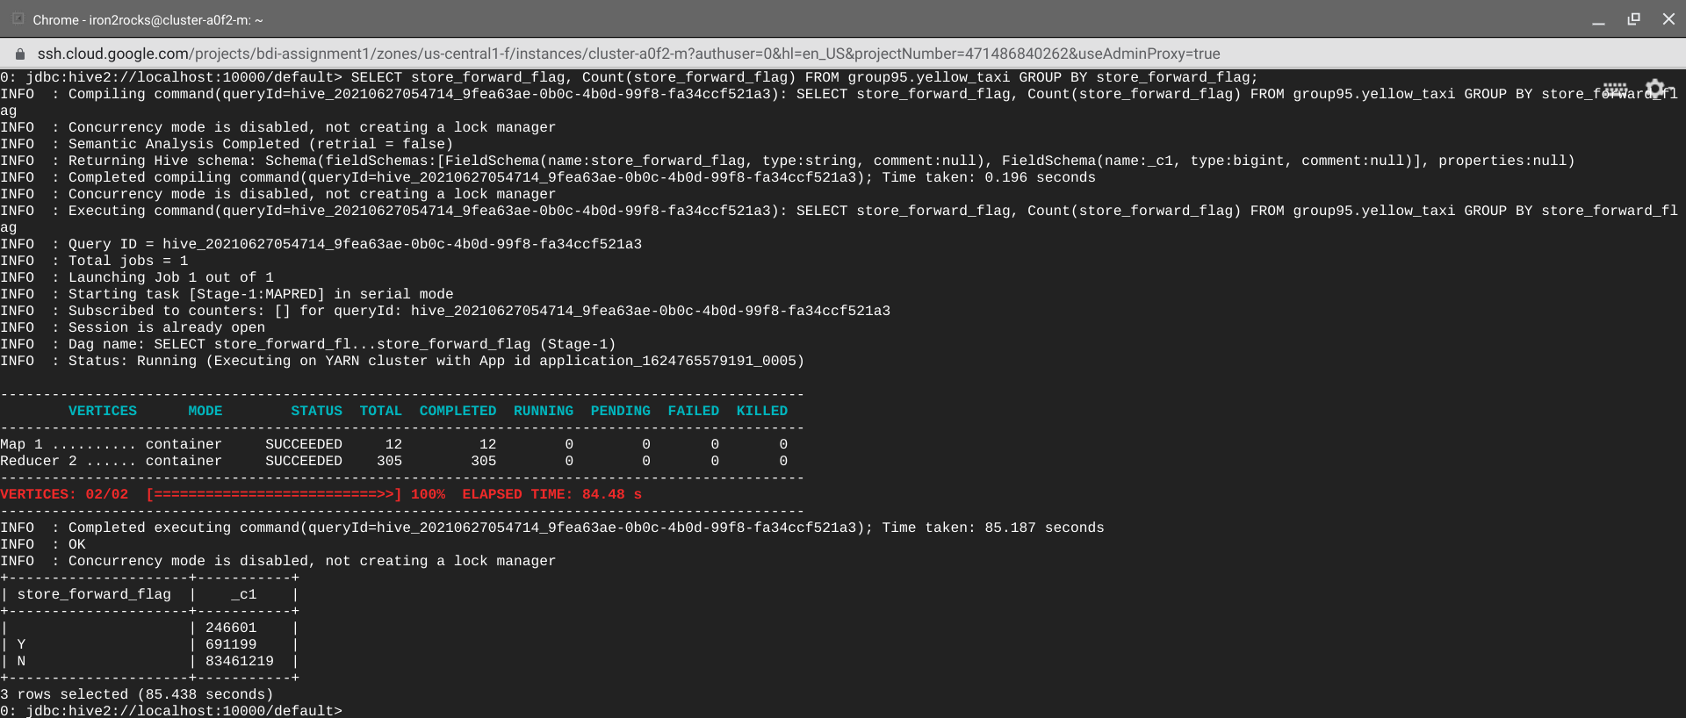

SELECT store_forward_flag, Count(store_forward_flag) FROM group95.green_taxi GROUP BY store_forward_flag;

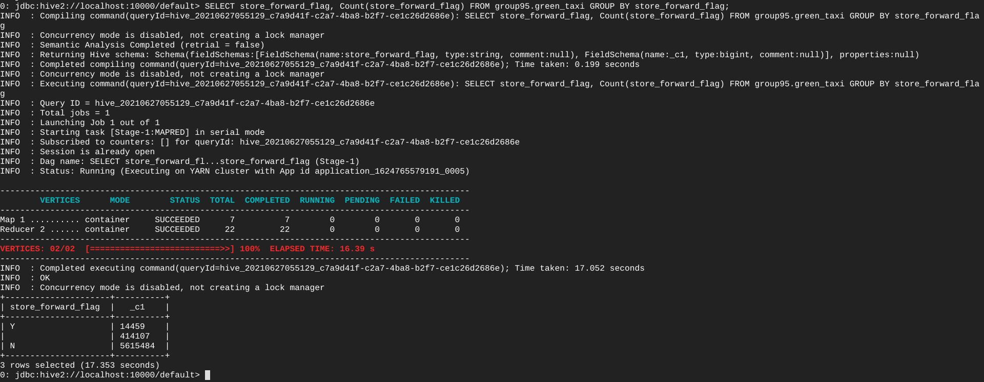

**Observation: From the above outputs, we can see that there are NULL/empty values for store forward flag which shouldn’t be considered for our further analysis.**

* **Vendor Id:**

SELECT vendorid, Count(vendorid) FROM group95.yellow_taxi GROUP BY vendorid;

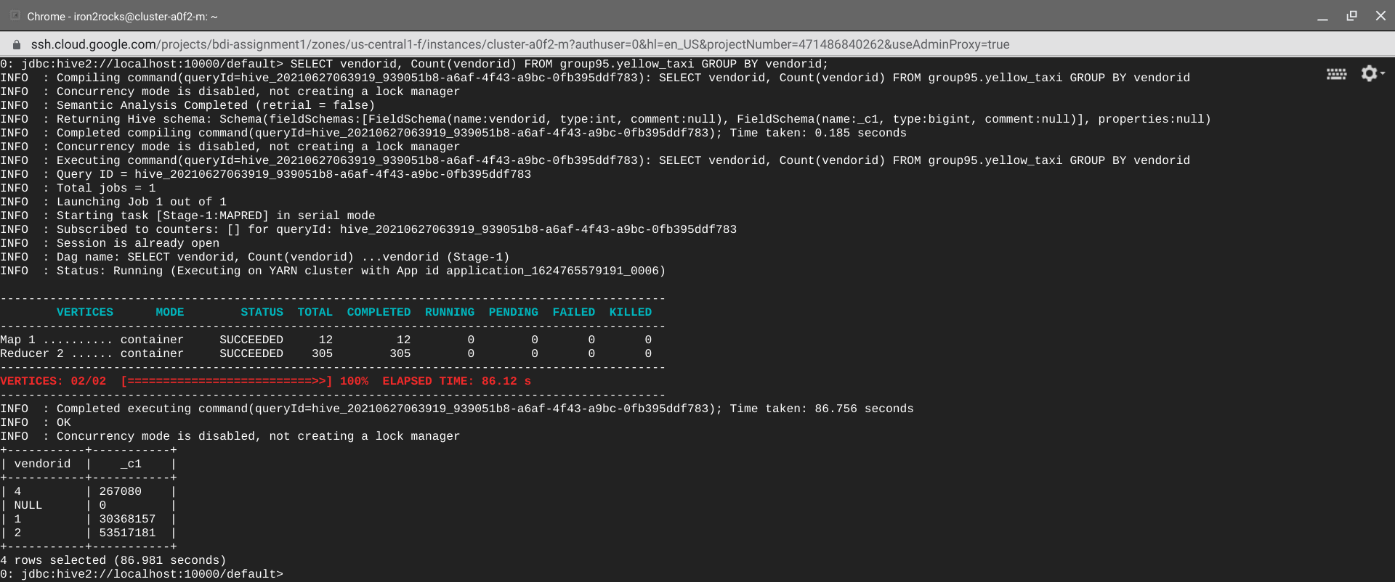

SELECT vendorid, Count(vendorid) FROM group95.green_taxi GROUP BY vendorid;

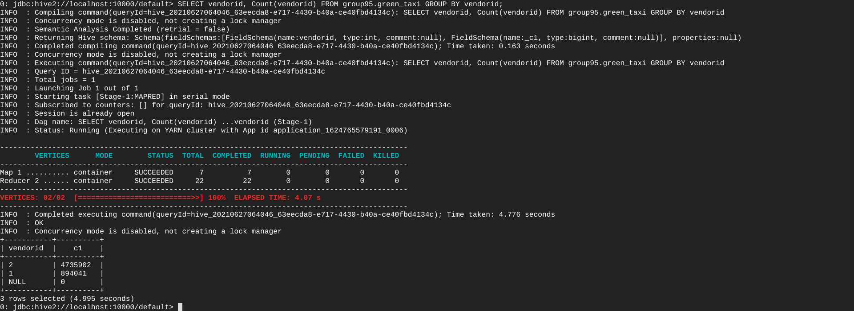

**Observation: As per the reference, vendor id is either 1 or 2, but we can see that there is data for 4 also which shouldn’t be considered for our further analysis.**

* **Payment type:**

SELECT payment_type, Count(payment_type) FROM group95.yellow_taxi GROUP BY payment_type;

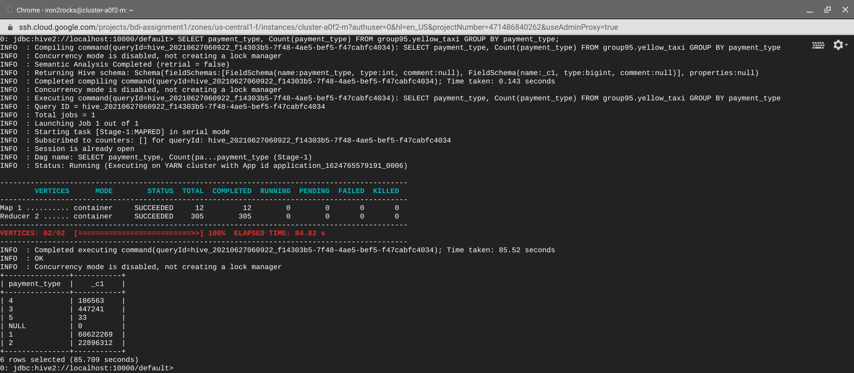

SELECT payment_type, Count(payment_type) FROM group95.green_taxi GROUP BY payment_type;

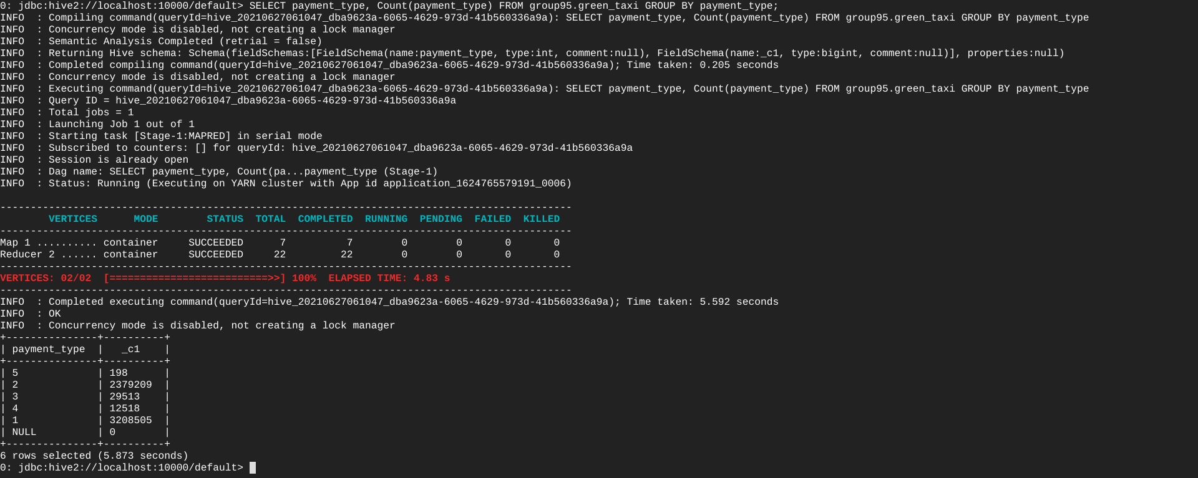

* **Cases where pickup time is greater than dropoff time:**

SELECT vendorid,Count(vendorid) FROM group95.yellow_taxi WHERE tpep_pickup_timestamp > tpep_dropoff_timestamp AND tpep_pickup_timestamp > '2019-01-01 00:00:00' AND tpep_pickup_timestamp > '2019-01-01 00:00:00' GROUP BY vendorid ;

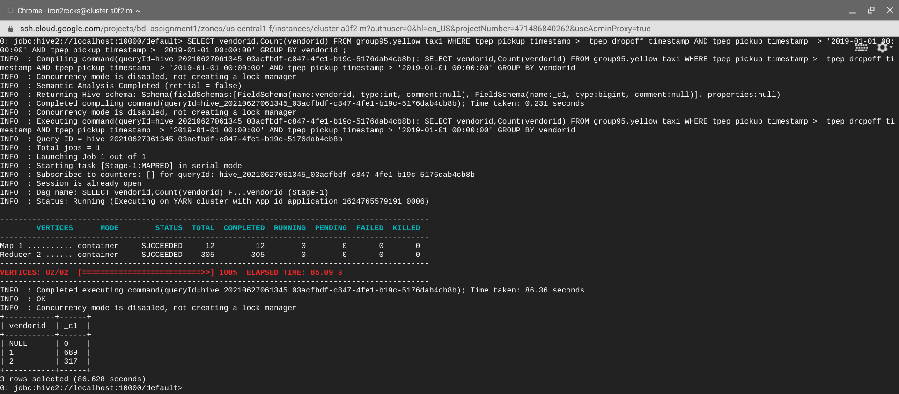

SELECT vendorid,Count(vendorid) FROM group95.green_taxi WHERE lpep_pickup_timestamp > lpep_dropoff_timestamp AND lpep_pickup_timestamp > '2019-01-01 00:00:00' AND lpep_pickup_timestamp > '2019-01-01 00:00:00' GROUP BY vendorid ;

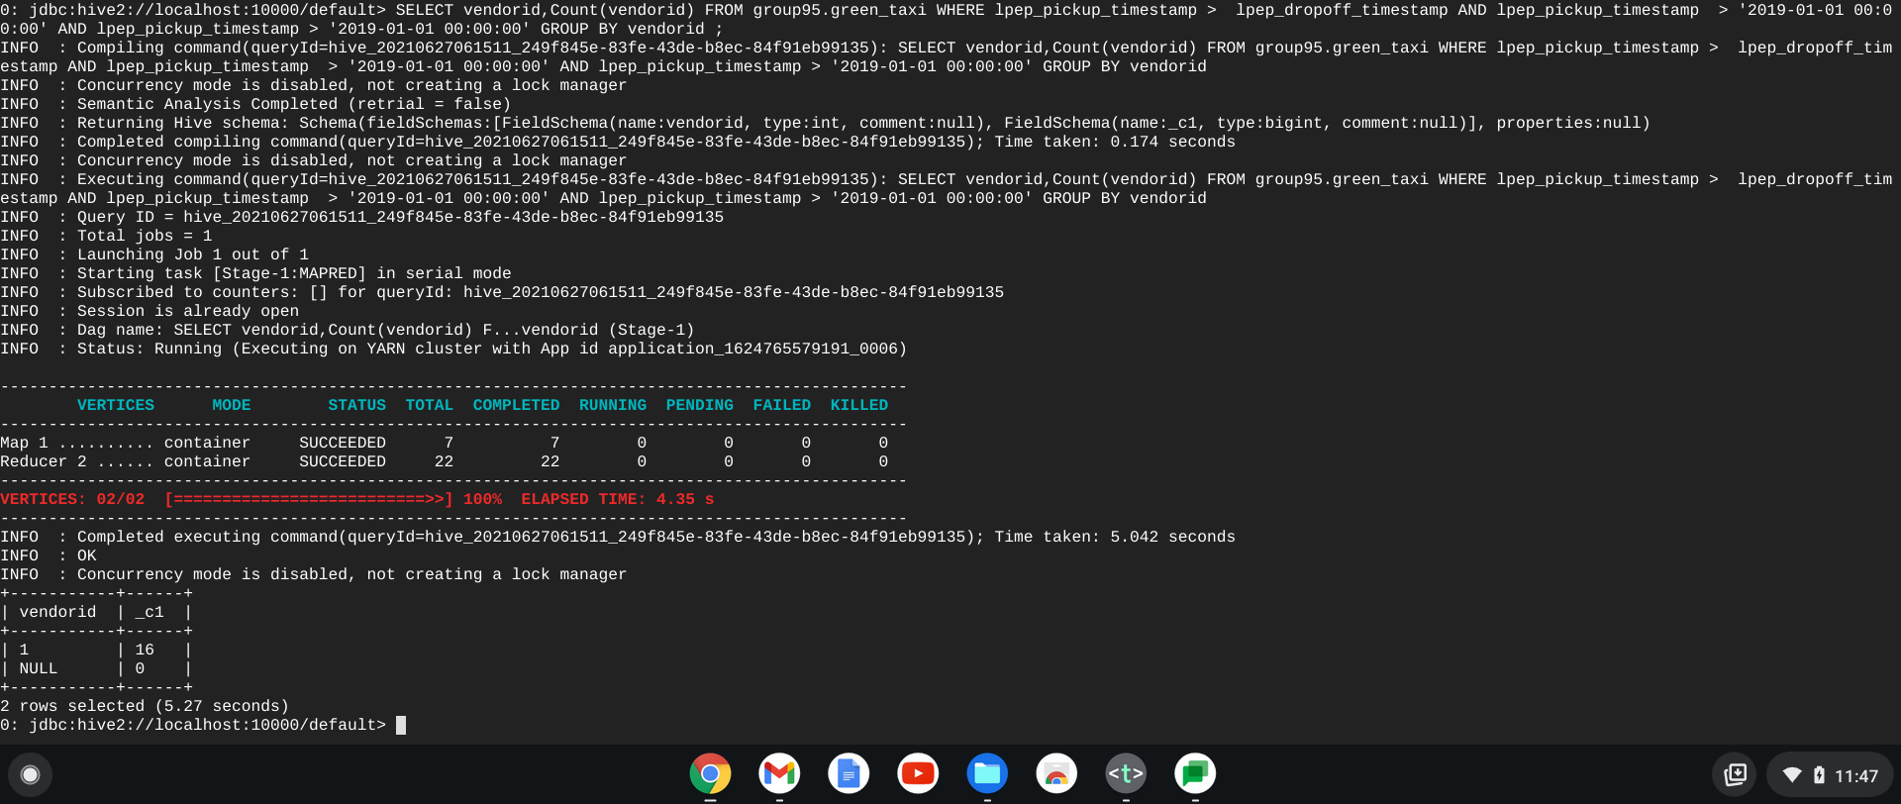

**Observation: From the above outputs, we can see that there are rows for which pickup time is greater than droptime which shouldn’t be considered for our further analysis.**

* **Fare/charges**: (Considering only yellow taxi data and generalizing the same for green taxi).

Ideal total_charge = sum(fare_charge, extra_charge , mta_tax_charge , tip_amount , tolls_charge , improvement_surcharge)

**Cases where sum is matching**:

SELECT Count(*) FROM group95.yellow_taxi WHERE total_charge = (fare_charge+extra_charge+mta_tax_charge+tip_amount+tolls_charge+improvement_surcharge);

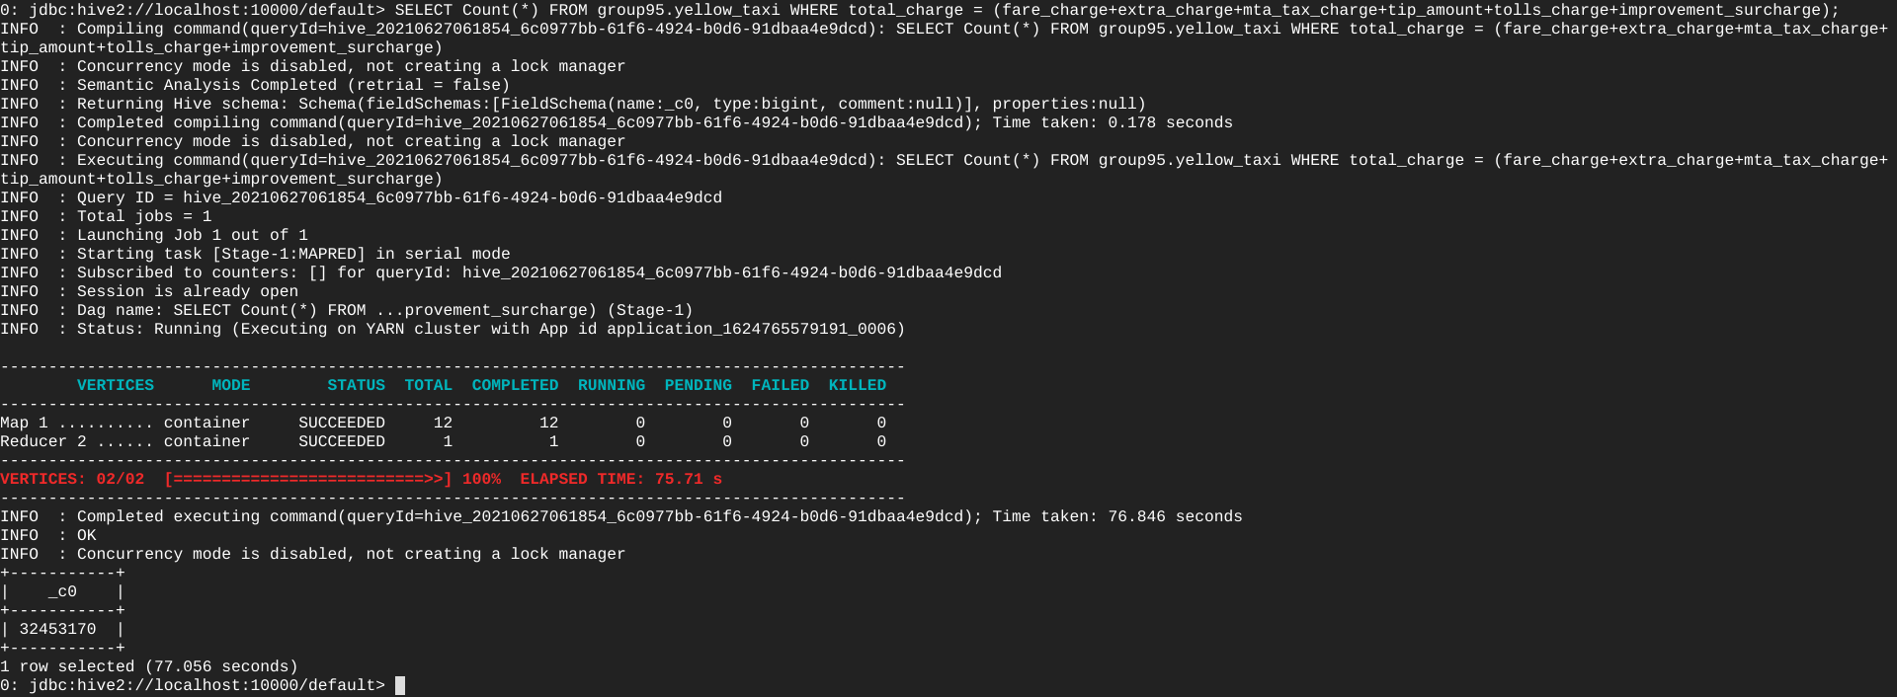

**Cases where the sum not matching:**

SELECT Count(*) FROM group95.yellow_taxi WHERE total_charge != (fare_charge+extra_charge+mta_tax_charge+tip_amount+tolls_charge+improvement_surcharge);

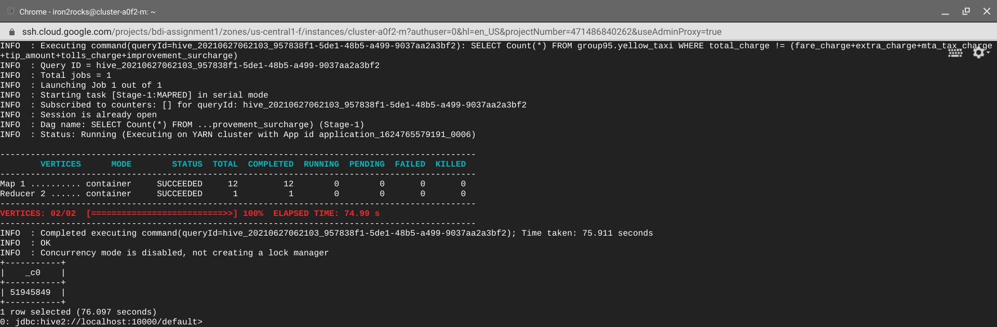

SELECT Count(*) FROM group95.yellow_taxi WHERE total_charge < (fare_charge+extra_charge+mta_tax_charge+tip_amount+tolls_charge+improvement_surcharge);

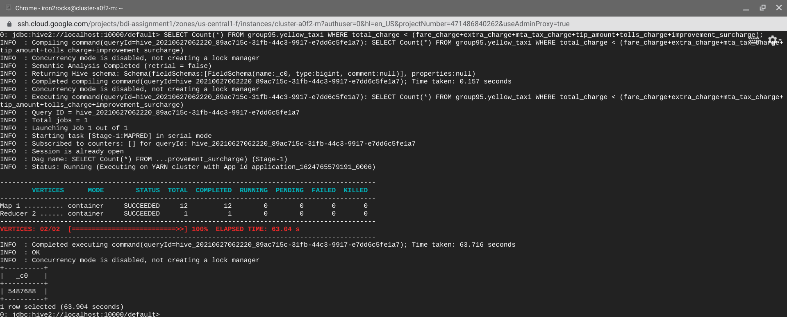

SELECT Count(*) FROM group95.yellow_taxi WHERE total_charge > (fare_charge+extra_charge+mta_tax_charge+tip_amount+tolls_charge+improvement_surcharge);

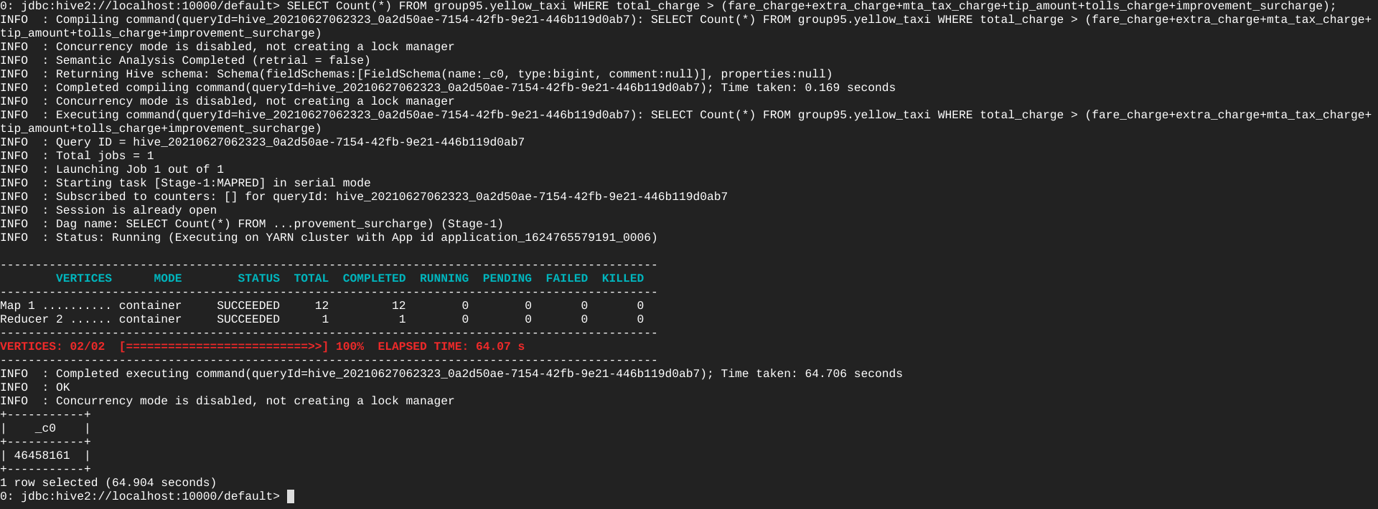

**Cases where fares are in negative numbers:**

SELECT Count(*) FROM group95.yellow_taxi WHERE fare_charge < 0 OR extra_charge < 0 OR mta_tax_charge < 0 OR tip_amount < 0 OR tolls_charge < 0 OR improvement_surcharge < 0 OR total_charge < 0;

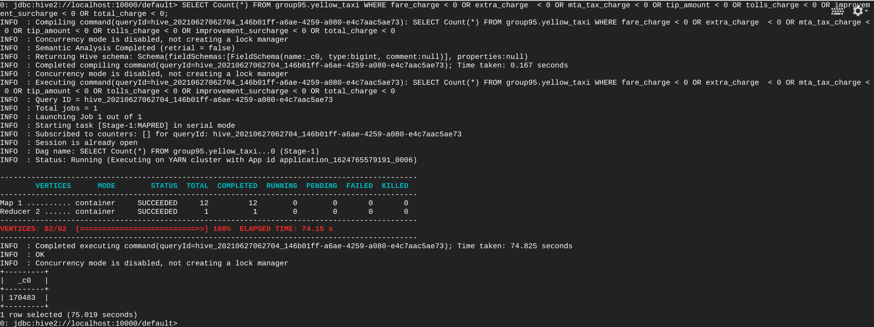

SELECT vendorid,Count(*) FROM group95.yellow_taxi WHERE fare_charge < 0 OR extra_charge < 0 OR mta_tax_charge < 0 OR tip_amount < 0 OR tolls_charge < 0 OR improvement_surcharge < 0 OR total_charge < 0 GROUP BY vendorid;

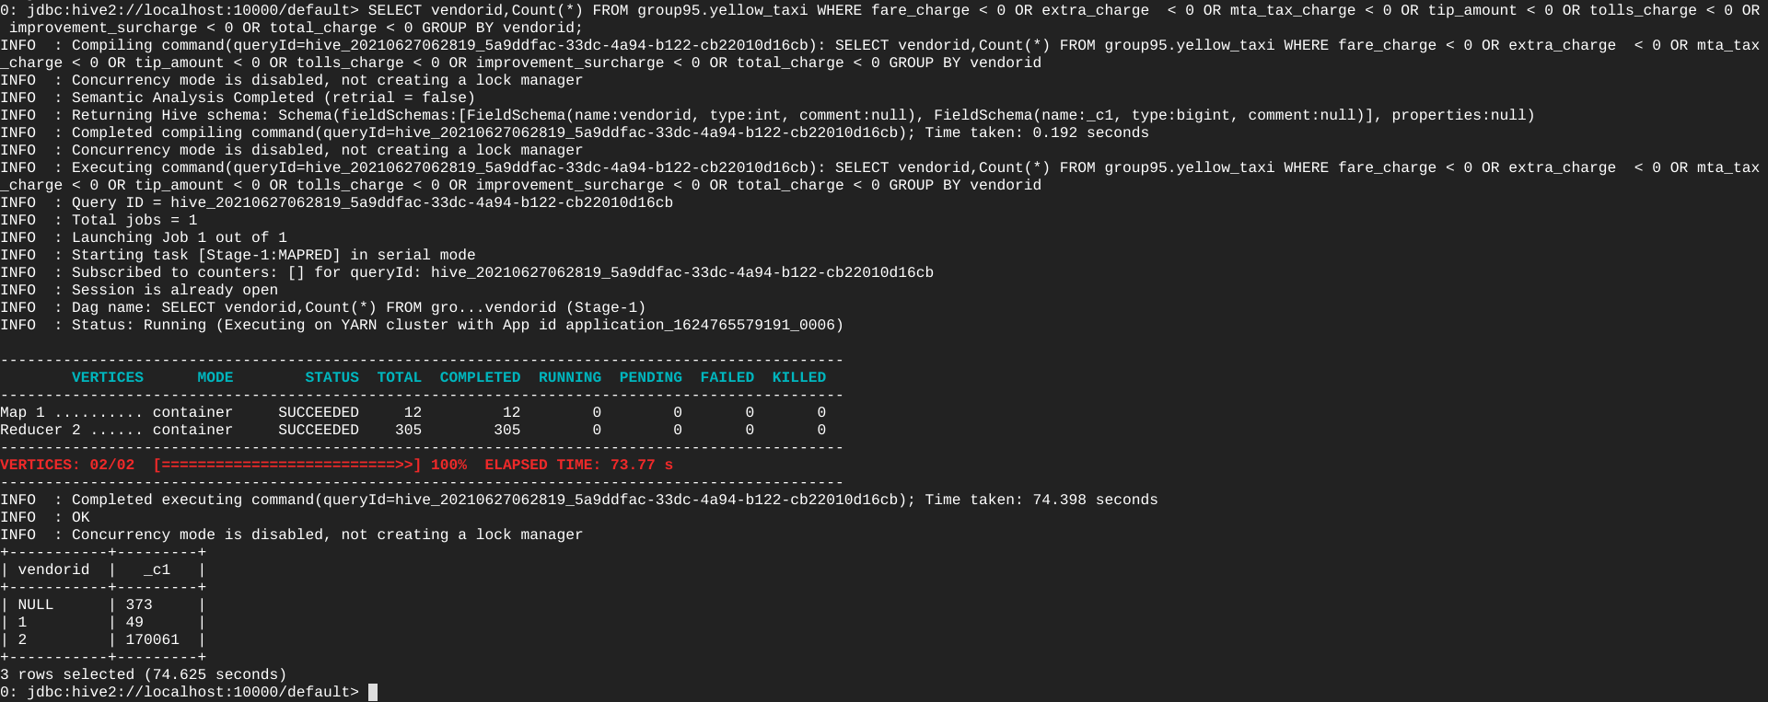

**Observation: From the above outputs, we can see that there is data where fare is negative and total charge is not matching with the charges present in calculating the total charge which shouldn’t be considered for our further analysis.**

* **Trip distance:**  (Considering only yellow taxi data and generalizing the same for green taxi).

→ It should be a positive number.

**Cases where trip distances are in negative numbers:**

SELECT Count(*) FROM group95.yellow_taxi WHERE trip_distance < 0;

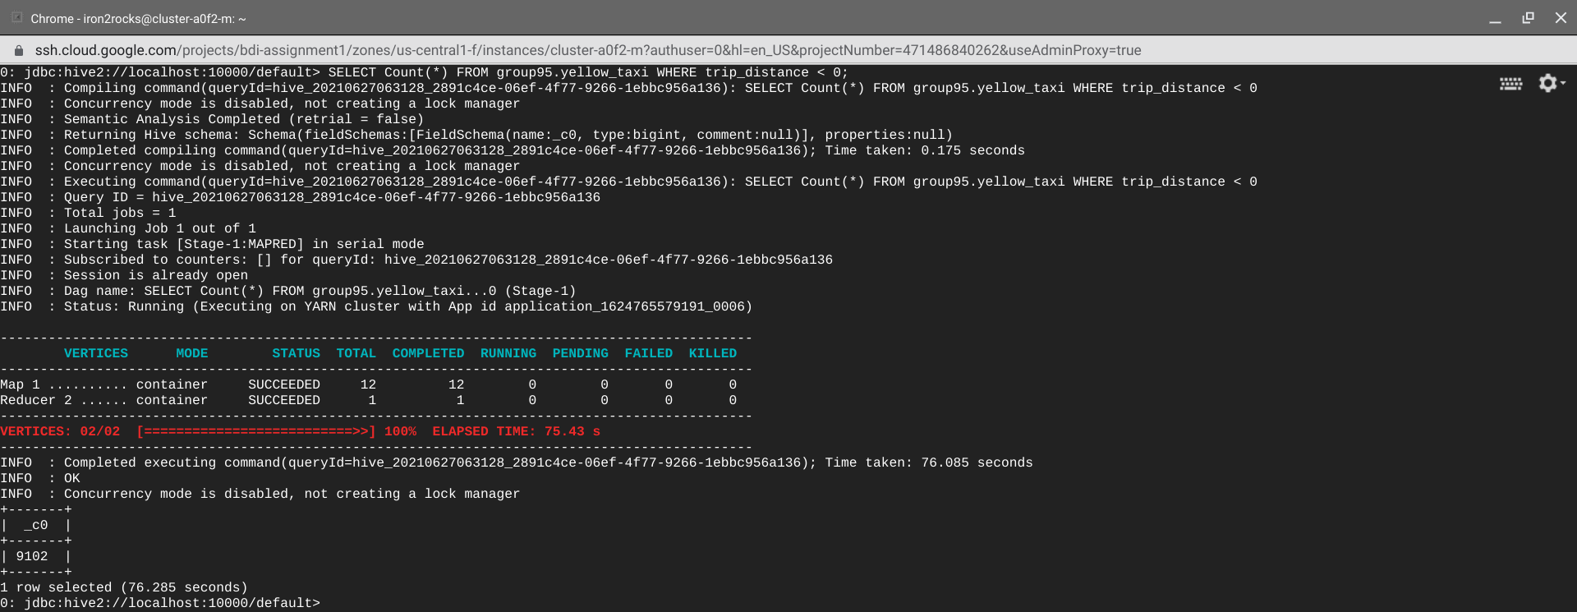

SELECT vendorid, Count(*) FROM group95.yellow_taxi WHERE trip_distance < 0 GROUP BY vendorid ;

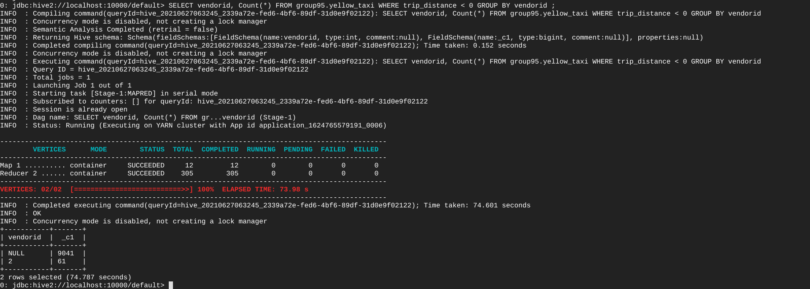

**Observation: From the above outputs, we can see that there is data where trip count is negative which shouldn’t be considered for our further analysis.**

* **Passenger count:** (Considering only yellow taxi data and generalizing the same for green taxi).

SELECT passenger_count,Count(passenger_Count) FROM group95.yellow_taxi GROUP BY passenger_Count;

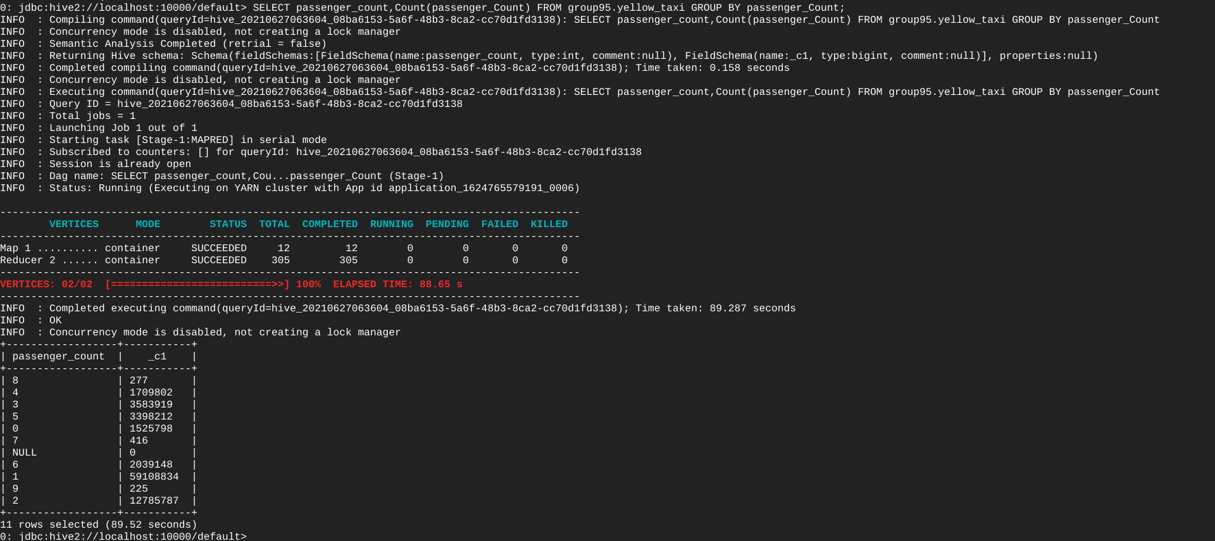

**Observation: From the above outputs, we can see that there is data where passenger count is 0 which shouldn’t be considered for our further analysis.**

**(There is also data with passenger count 7, 8, 9 which might not be ideal but considering bigger vehicles as taxis in these regions, considering this data for our analysis).**

* **Checking Distinct Year and months available in the Datasets for pickup and drop off:**

SELECT DISTINCT Month(tpep_pickup_datetime),  
                Year(tpep_pickup_datetime)  
FROM   group95.yellow_taxi;

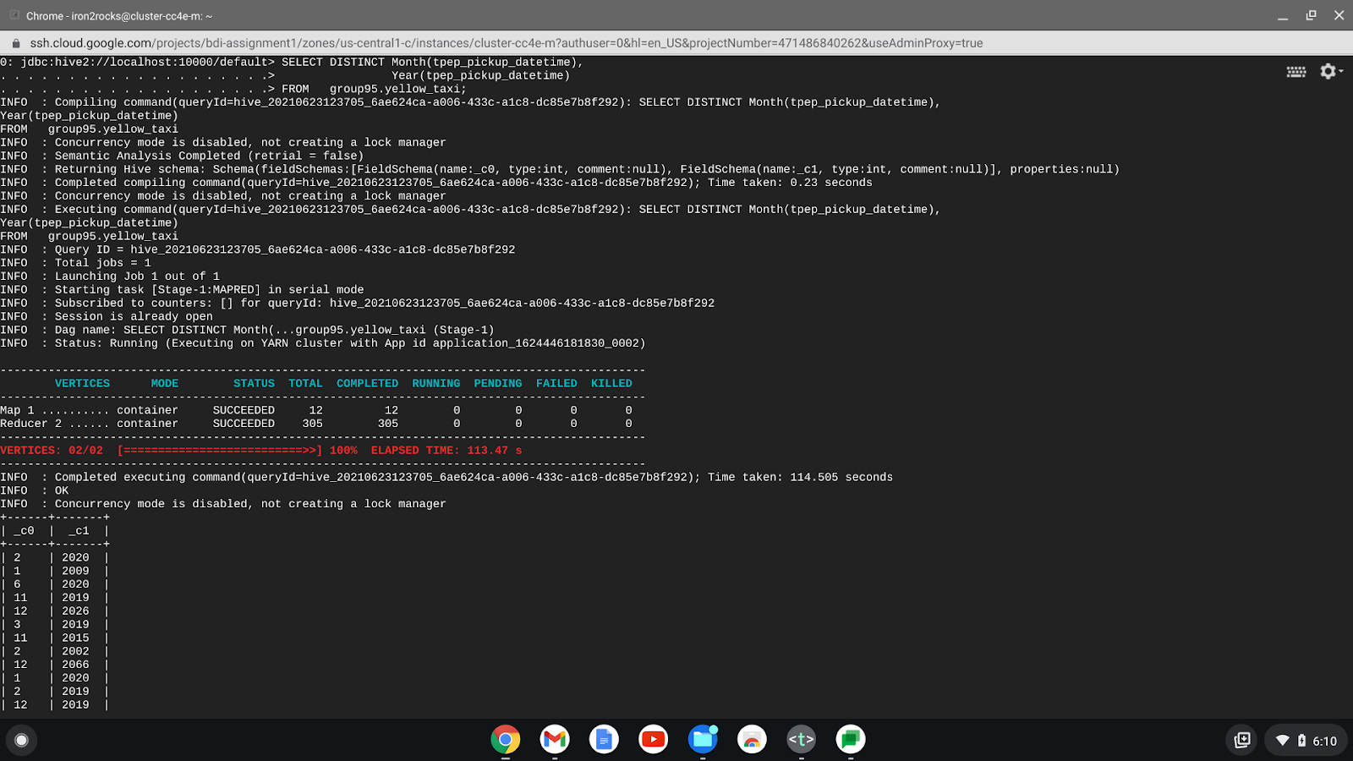

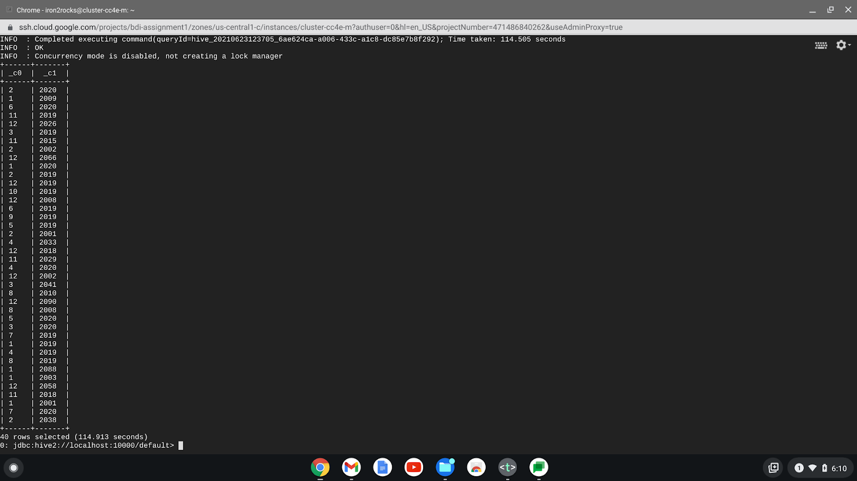

SELECT DISTINCT Month(lpep_pickup_datetime),  
                Year(lpep_pickup_datetime)  
FROM   group95.green_taxi;

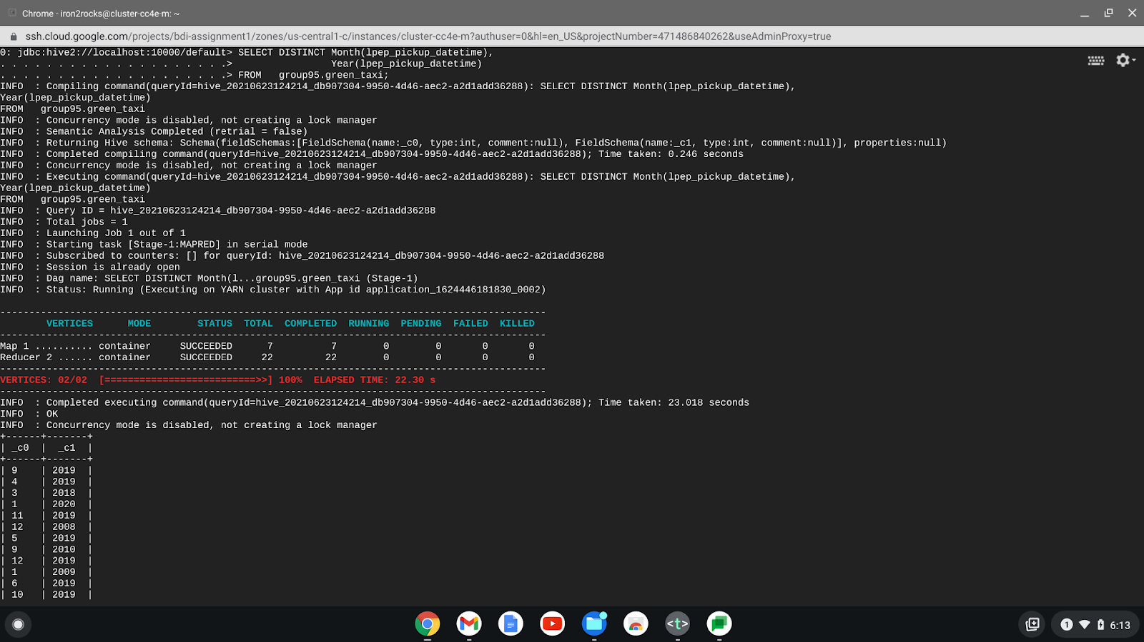

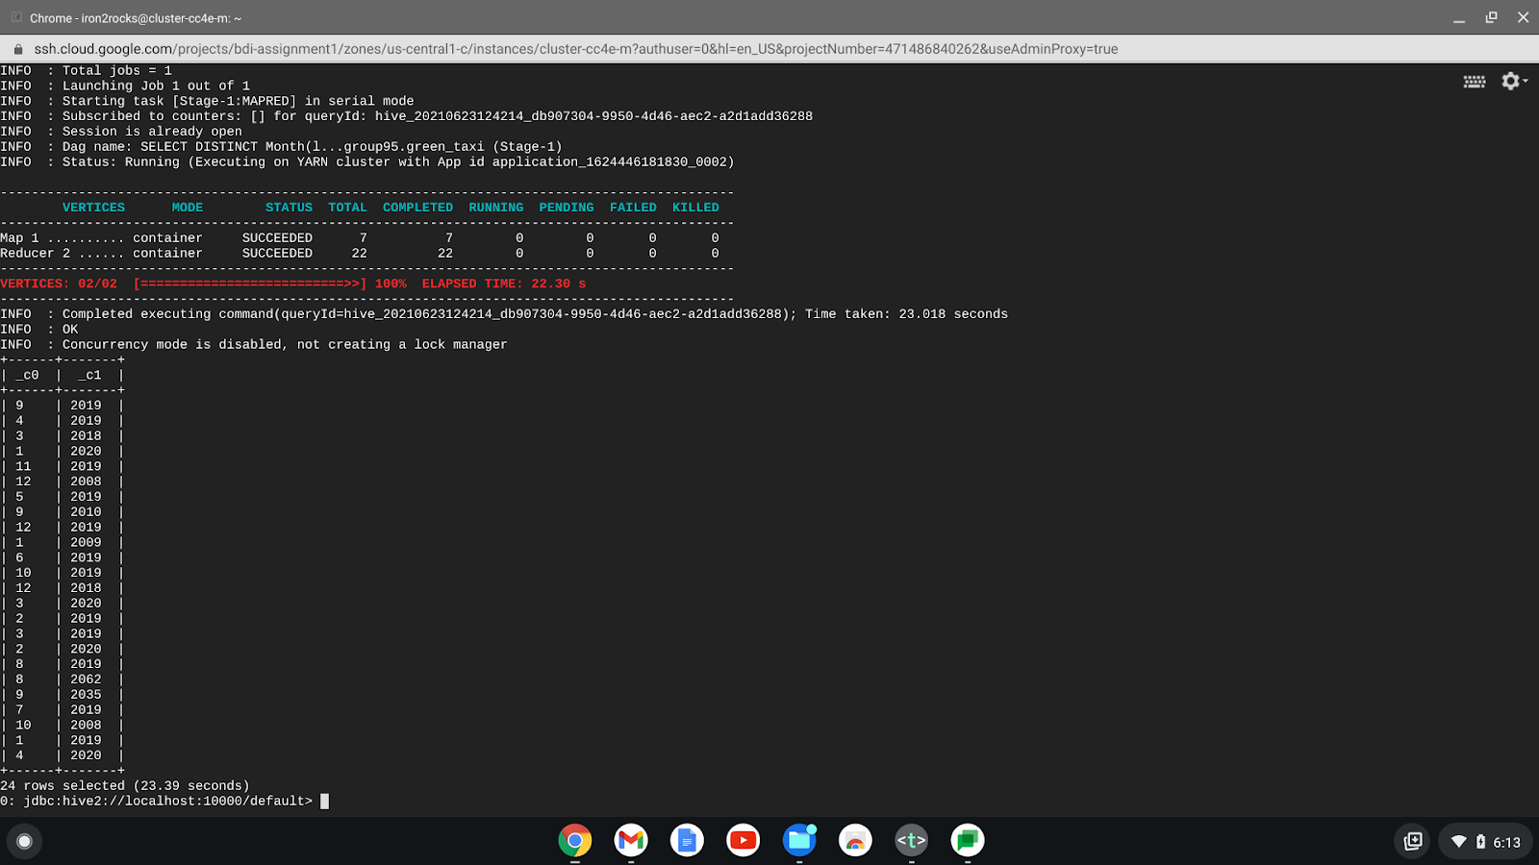

**Observation: Though only data of 2019 is downloaded/added from the resource, we can see that we have years other than 2019 also, we should only filter the data with 2019 and the rest** **shouldn’t be considered for our further analysis.**

1. **Created new tables to consider only 2019 data and also applying filters to consider valid data (using the below code) to answer the questions:**

CREATE TABLE group95.yellow_taxi_2019 AS

SELECT *

FROM group95.yellow_taxi

WHERE Year(tpep_pickup_timestamp) == 2019

AND Year(tpep_dropoff_timestamp) == 2019

AND vendorid IN ( 1, 2 )

AND Unix_timestamp(tpep_pickup_timestamp) <

Unix_timestamp(tpep_dropoff_timestamp)

AND passenger_count > 0

AND total_charge = (fare_charge+extra_charge+mta_tax_charge+tip_amount+tolls_charge+improvement_surcharge)

AND fare_charge > 0

AND extra_charge > 0

AND mta_tax_charge > 0

AND tip_amount > 0

AND tolls_charge > 0

AND improvement_surcharge > 0

AND total_charge > 0 and trip_distance > 0

AND store_forward_flag in ('Y', 'N')

AND rate_code_id != 99

AND pickup_location_id != dropoff_location_id;

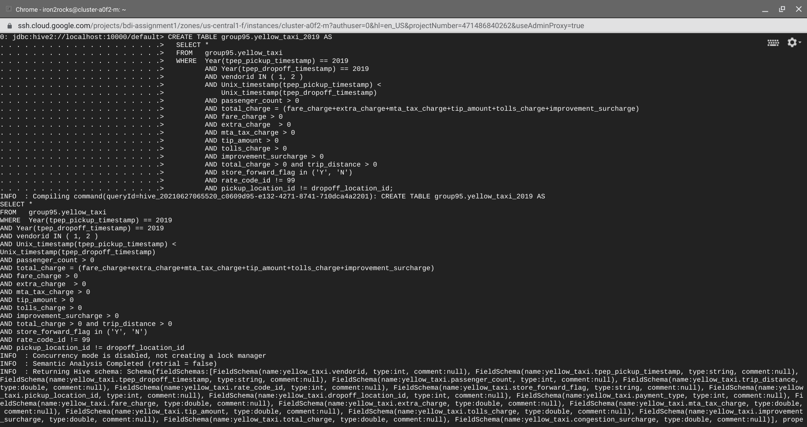

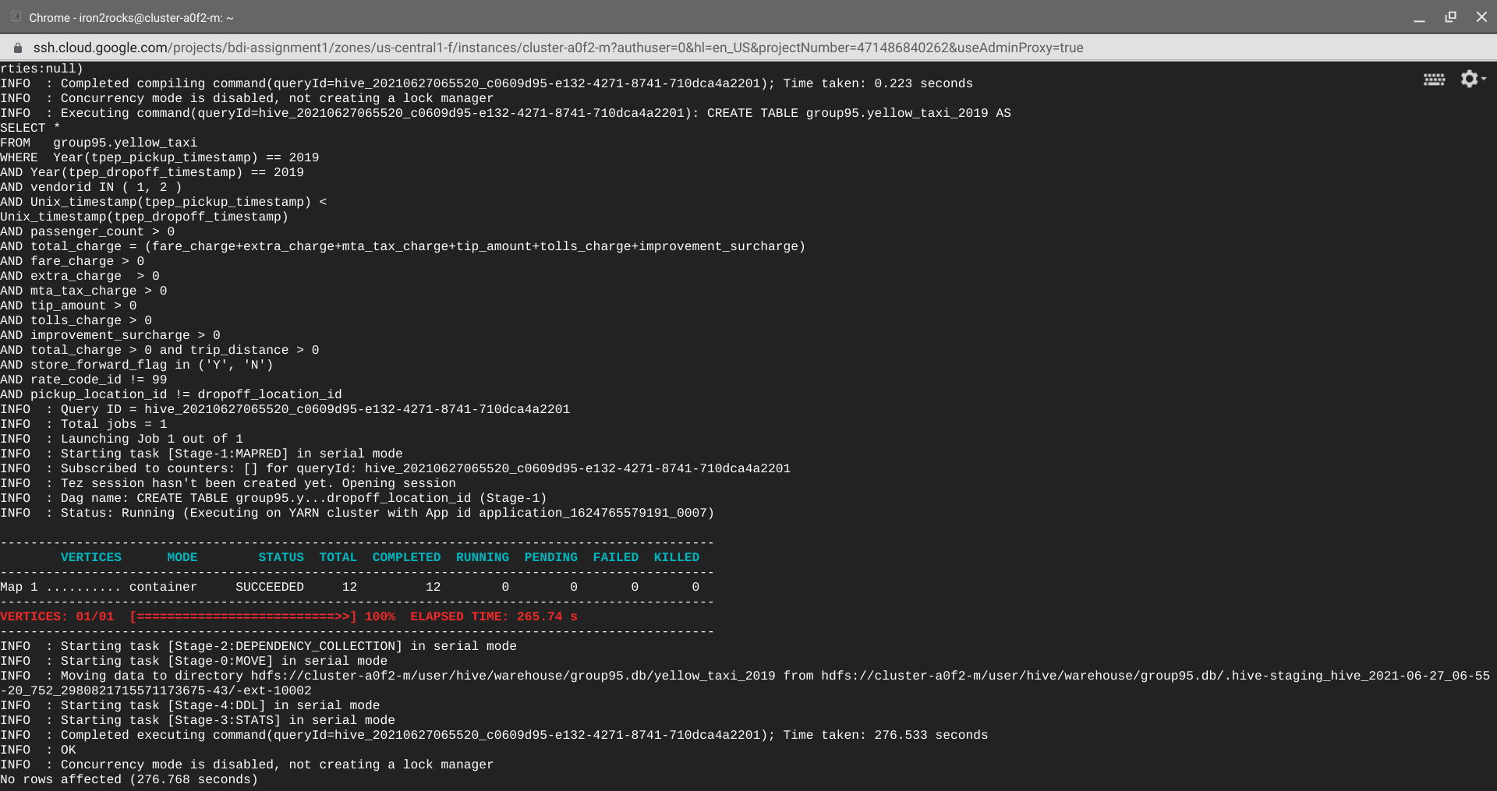

CREATE TABLE group95.green_taxi_2019 AS

SELECT *

FROM group95.green_taxi

WHERE Year(lpep_pickup_datetime) == 2019

AND Year(lpep_dropoff_datetime) == 2019

AND vendorid IN ( 1, 2 )

AND Unix_timestamp(lpep_pickup_datetime) <

Unix_timestamp(lpep_dropoff_datetime)

AND passenger_count > 0

AND total_charge = (fare_charge+extra_charge+mta_tax_charge+tip_amount+tolls_charge+improvement_surcharge)

AND fare_charge > 0

AND extra_charge > 0

AND mta_tax_charge > 0

AND tip_amount > 0

AND tolls_charge > 0

AND improvement_surcharge > 0

AND total_charge > 0 and trip_distance > 0

AND store_forward_flag in ('Y', 'N')

AND rate_code_id != 99

AND pickup_location_id != dropoff_location_id;

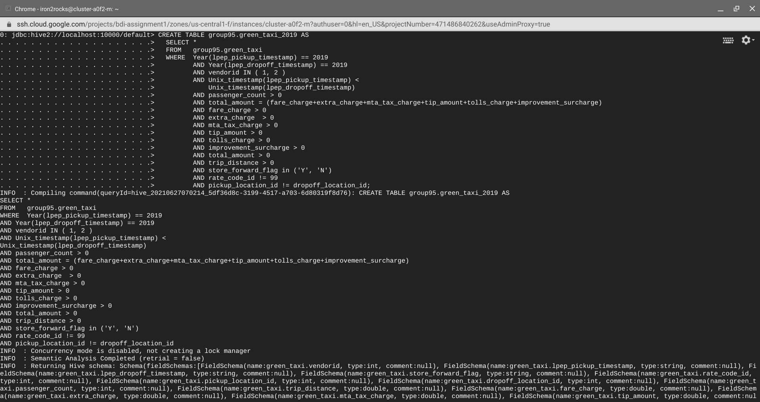

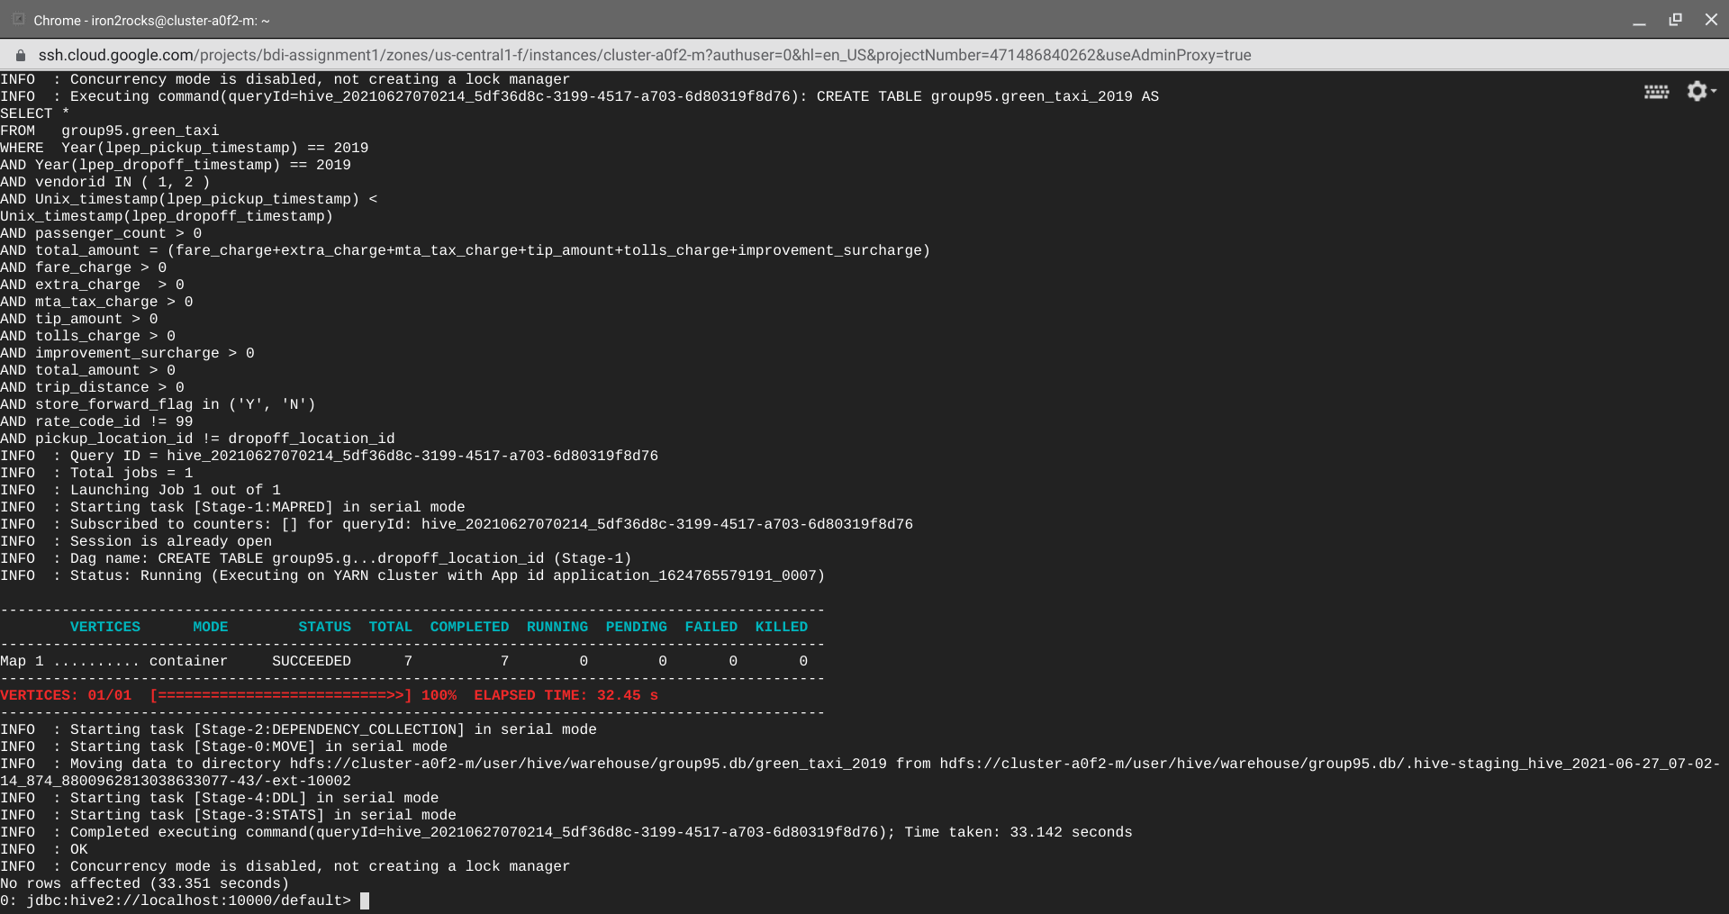

**Answer to Asked Questions with Output**

1. **Which vendor provides the most useful data ?**

**Code:**

SELECT vendorid AS Vendor_Id,  
       COUNT(*) AS Num_Records  
FROM   group95.yellow_taxi_2019  
GROUP  BY vendorid  
ORDER  BY vendorid;

**Output**:

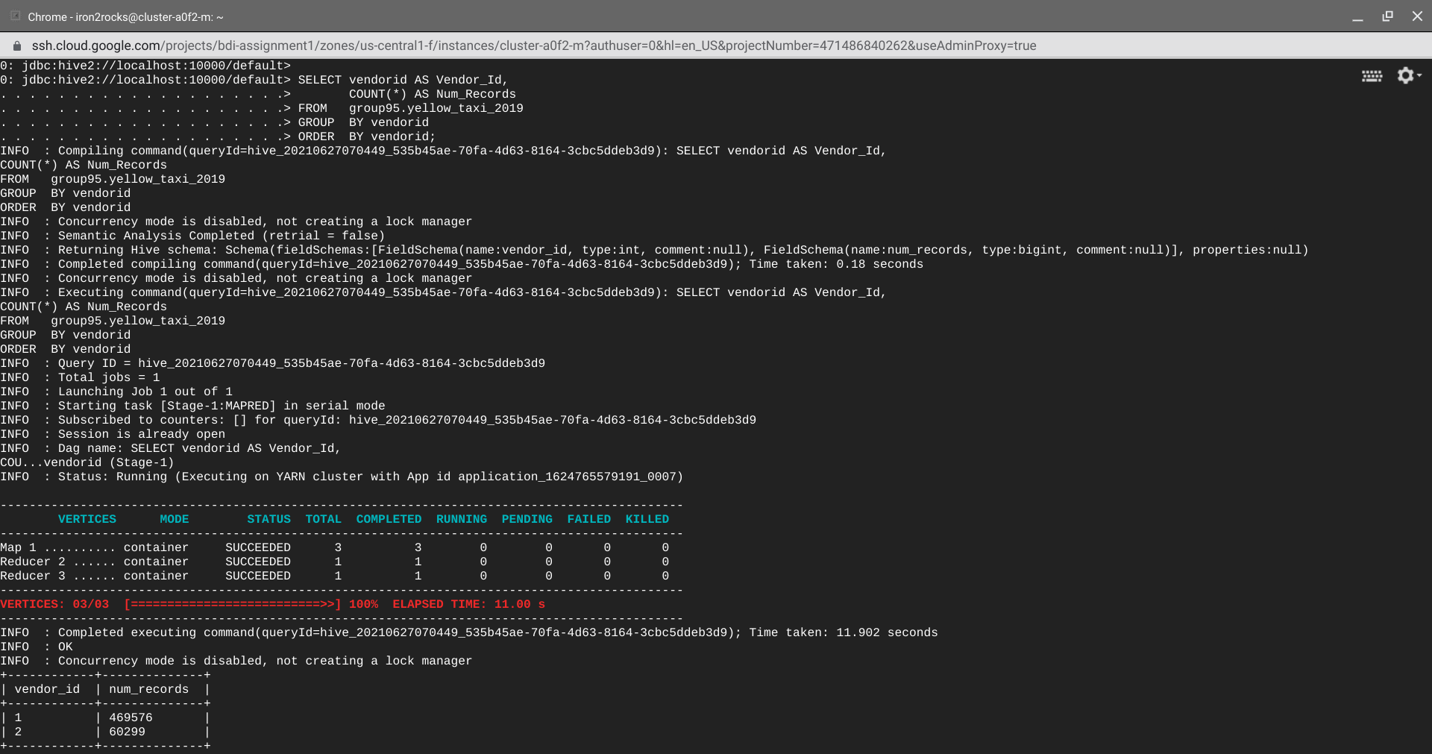

**Code:**

SELECT vendorid AS Vendor_Id,  
       COUNT(*) AS Num_Records  
FROM   group95.green_taxi_2019  
GROUP  BY vendorid  
ORDER  BY vendorid;

**Output:**

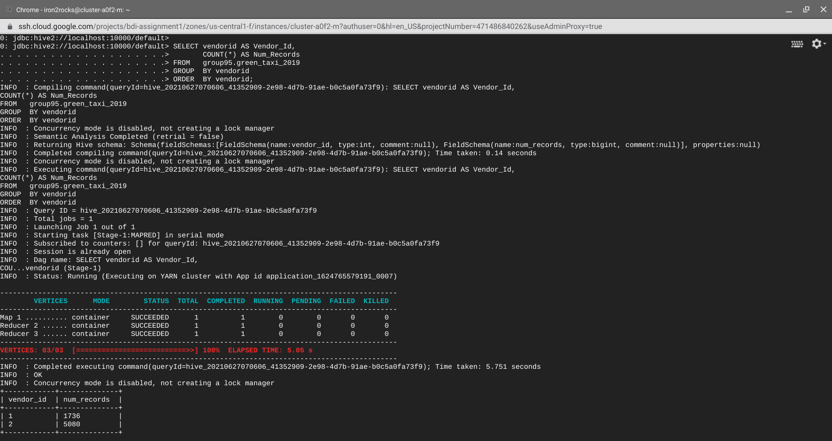

**Final Solution**

From both the above outputs, we can observe that for Yellow taxi Vendor 1 has more data and for Green taxi, Vendor 2 has more data.

1. **Find the month wise trip count, average distance and average passenger count**

**from the trips completed by yellow and green taxis in 2019. Summary**

**visualizations will be preferred for better analysis.**

**Code**

SELECT Year(tpep_pickup_datetime)  AS Year,  
       Month(tpep_pickup_datetime) AS Month,  
       Count(*)                    AS Trip_Count,  
       Avg(passenger_count)        AS average_passengers_pertrip,  
       Avg(trip_distance)          AS average_trip_distance  
FROM   group95.yellow_taxi_2019  
GROUP  BY Year(tpep_pickup_datetime),  
          Month(tpep_pickup_datetime)  
ORDER  BY month DESC;

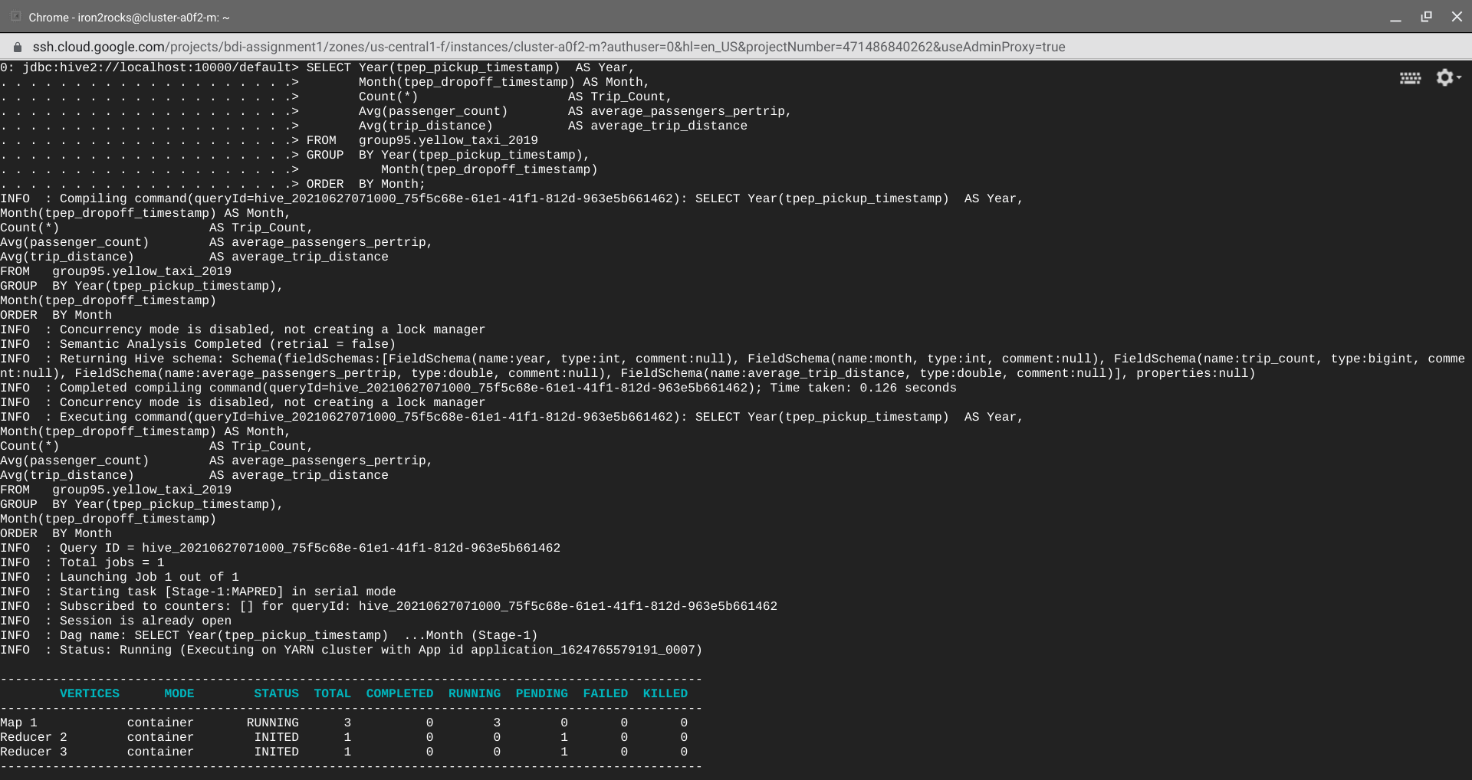

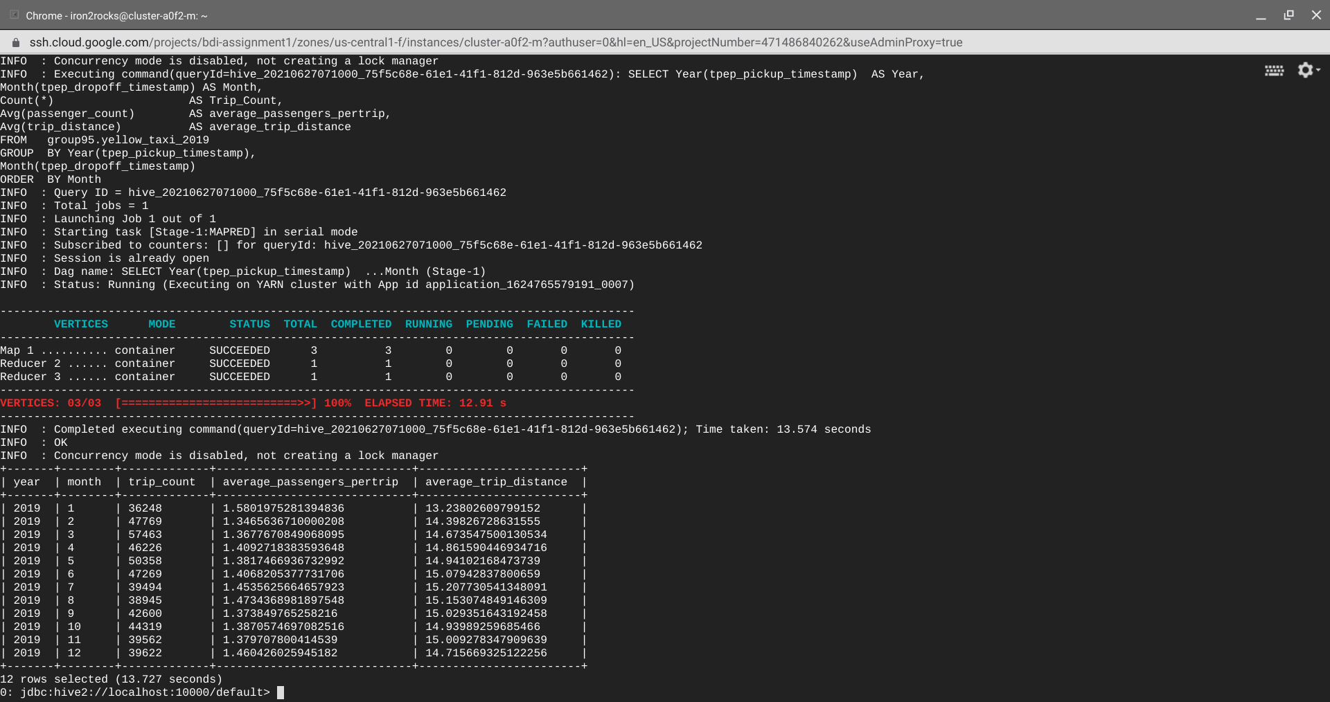

SELECT Year(lpep_pickup_datetime)  AS Year,  
       Month(lpep_pickup_datetime) AS Month,  
       Count(*)                    AS Trip_Count,  
       Avg(passenger_count)        AS average_passengers_pertrip,  
       Avg(trip_distance)          AS average_trip_distance  
FROM   group95.green_taxi_2019  
GROUP  BY Year(lpep_pickup_datetime),  
          Month(lpep_pickup_datetime)  
ORDER  BY month DESC;

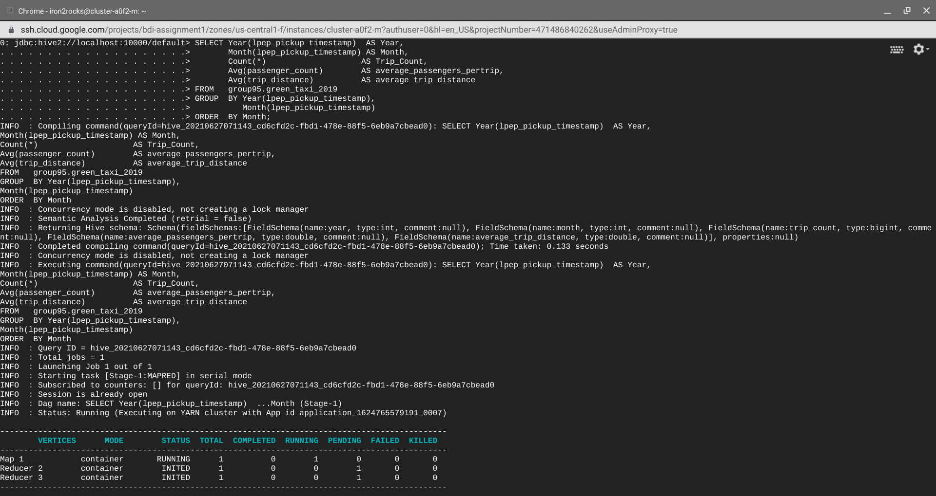

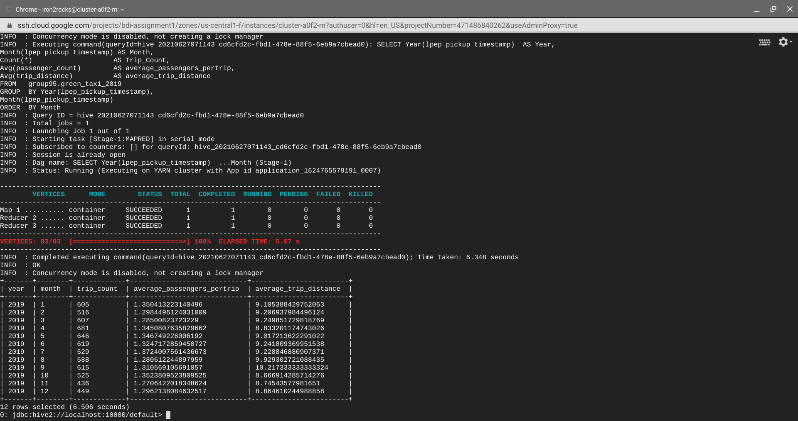

**Visualization**

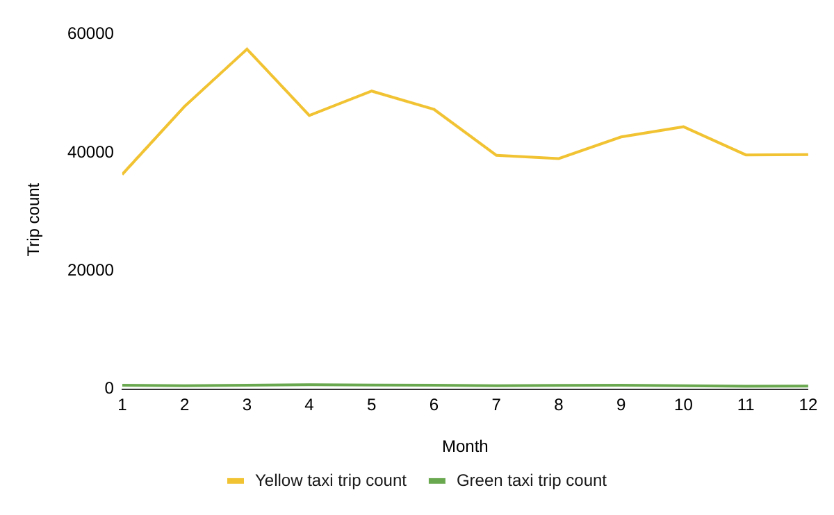

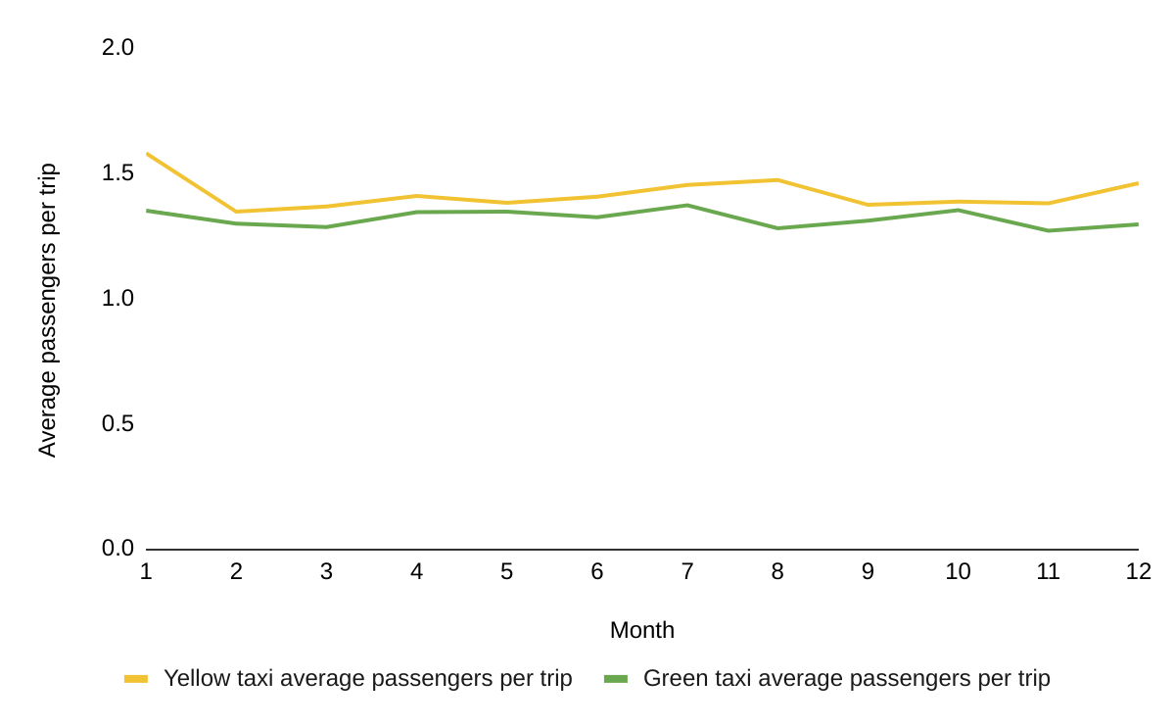

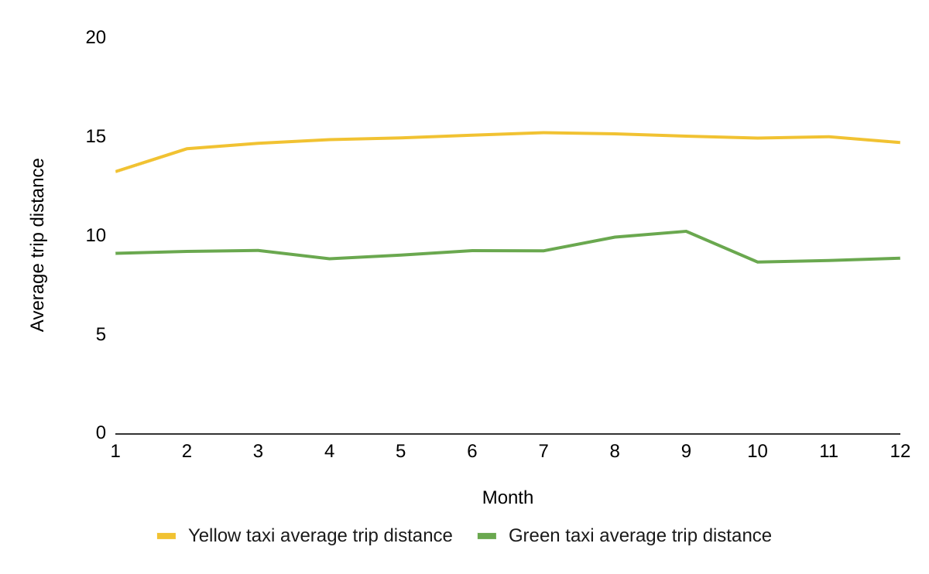

Yellow taxi:

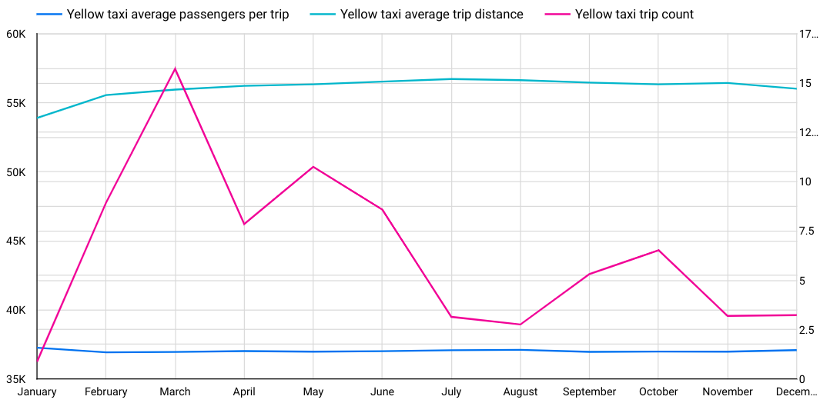

Green taxi:

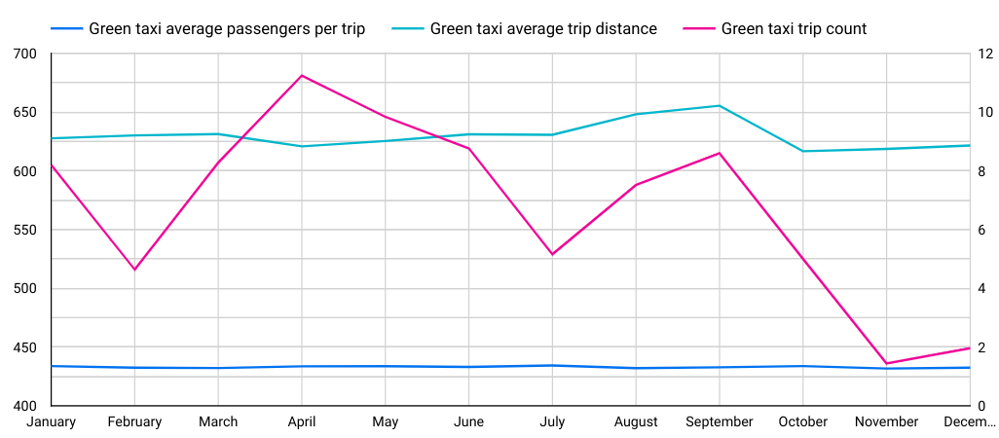

1. **Find out the five busiest routes served by the yellow and green taxis during 2019.**

**The name of start and drop points to be provided.**

**Code**

SELECT Concat(pulocationid, '-', dolocationid) AS combined_trip_detail,  
       Count(*)                                AS Trip_Count  
FROM   group95.yellow_taxi_2019  
GROUP  BY Concat(pulocationid, '-', dolocationid)  
ORDER  BY trip_count DESC

LIMIT 5;

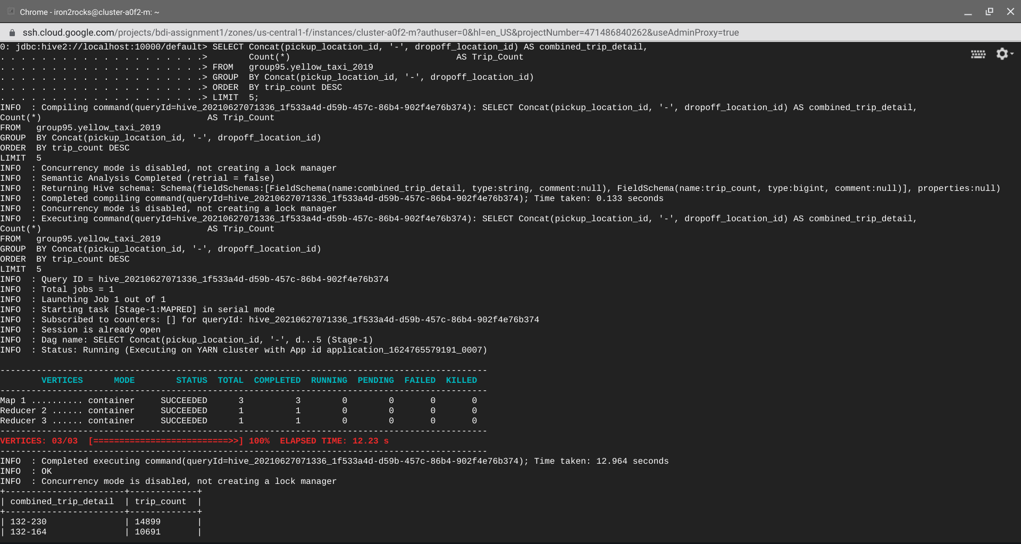

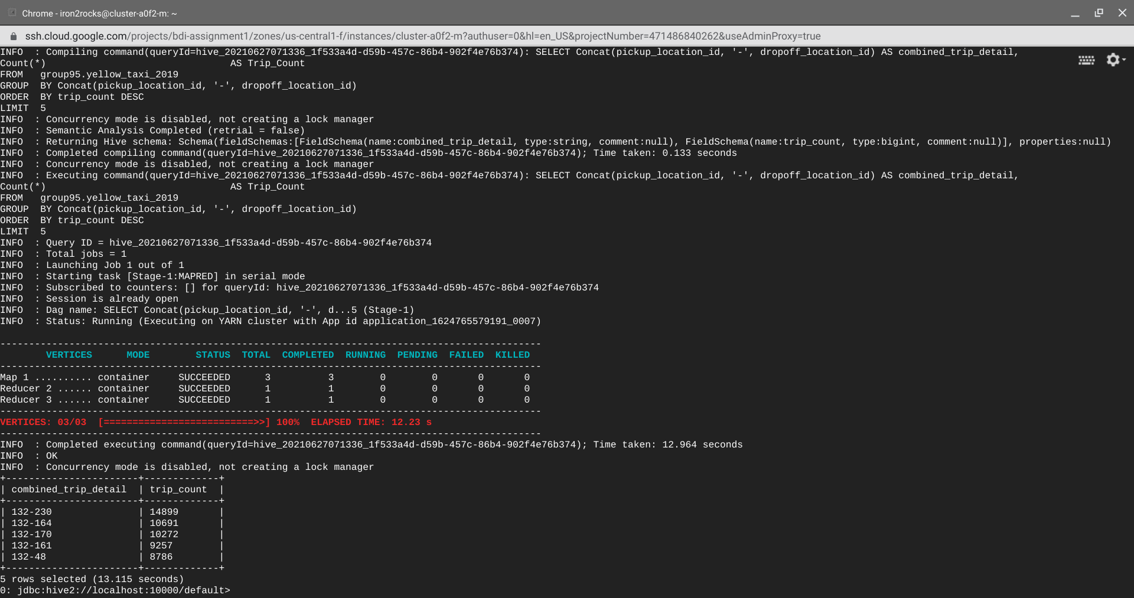

SELECT Concat(pulocationid, '-', dolocationid) AS combined_trip_detail,  
       Count(*)                                AS Trip_Count  
FROM   group95.green_taxi_2019  
GROUP  BY Concat(pulocationid, '-', dolocationid)  
ORDER  BY trip_count DESC

LIMIT 5;

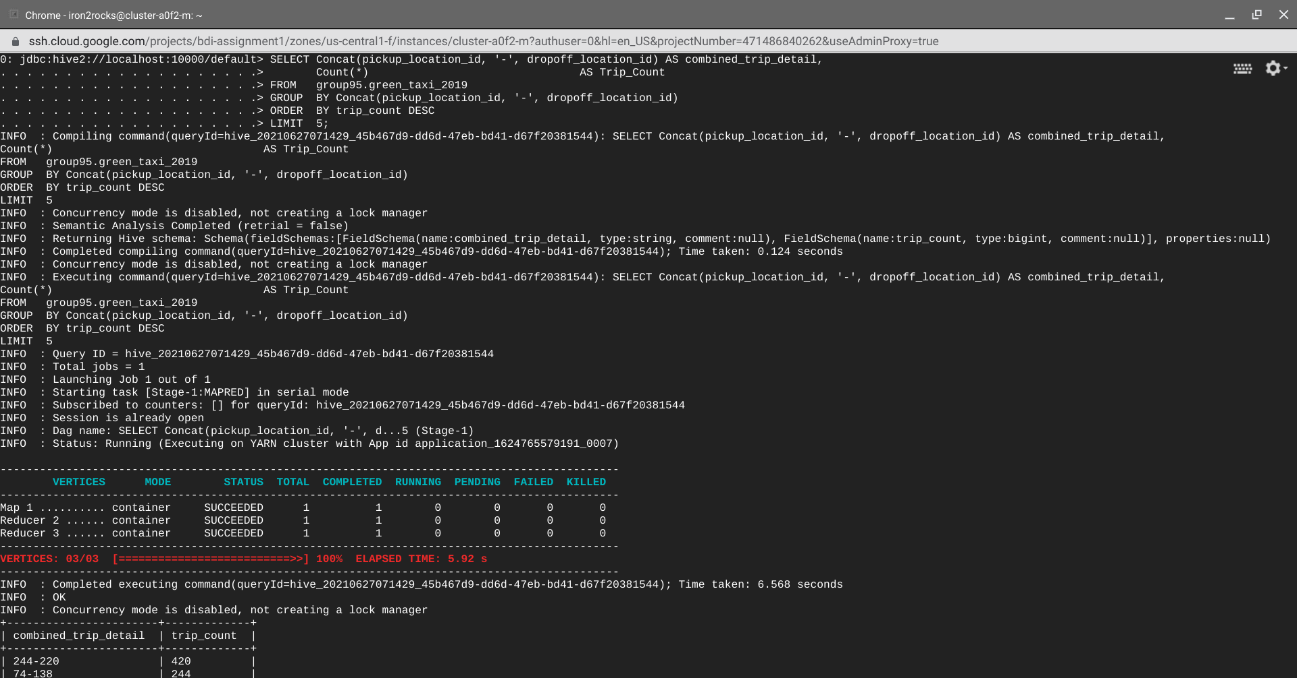

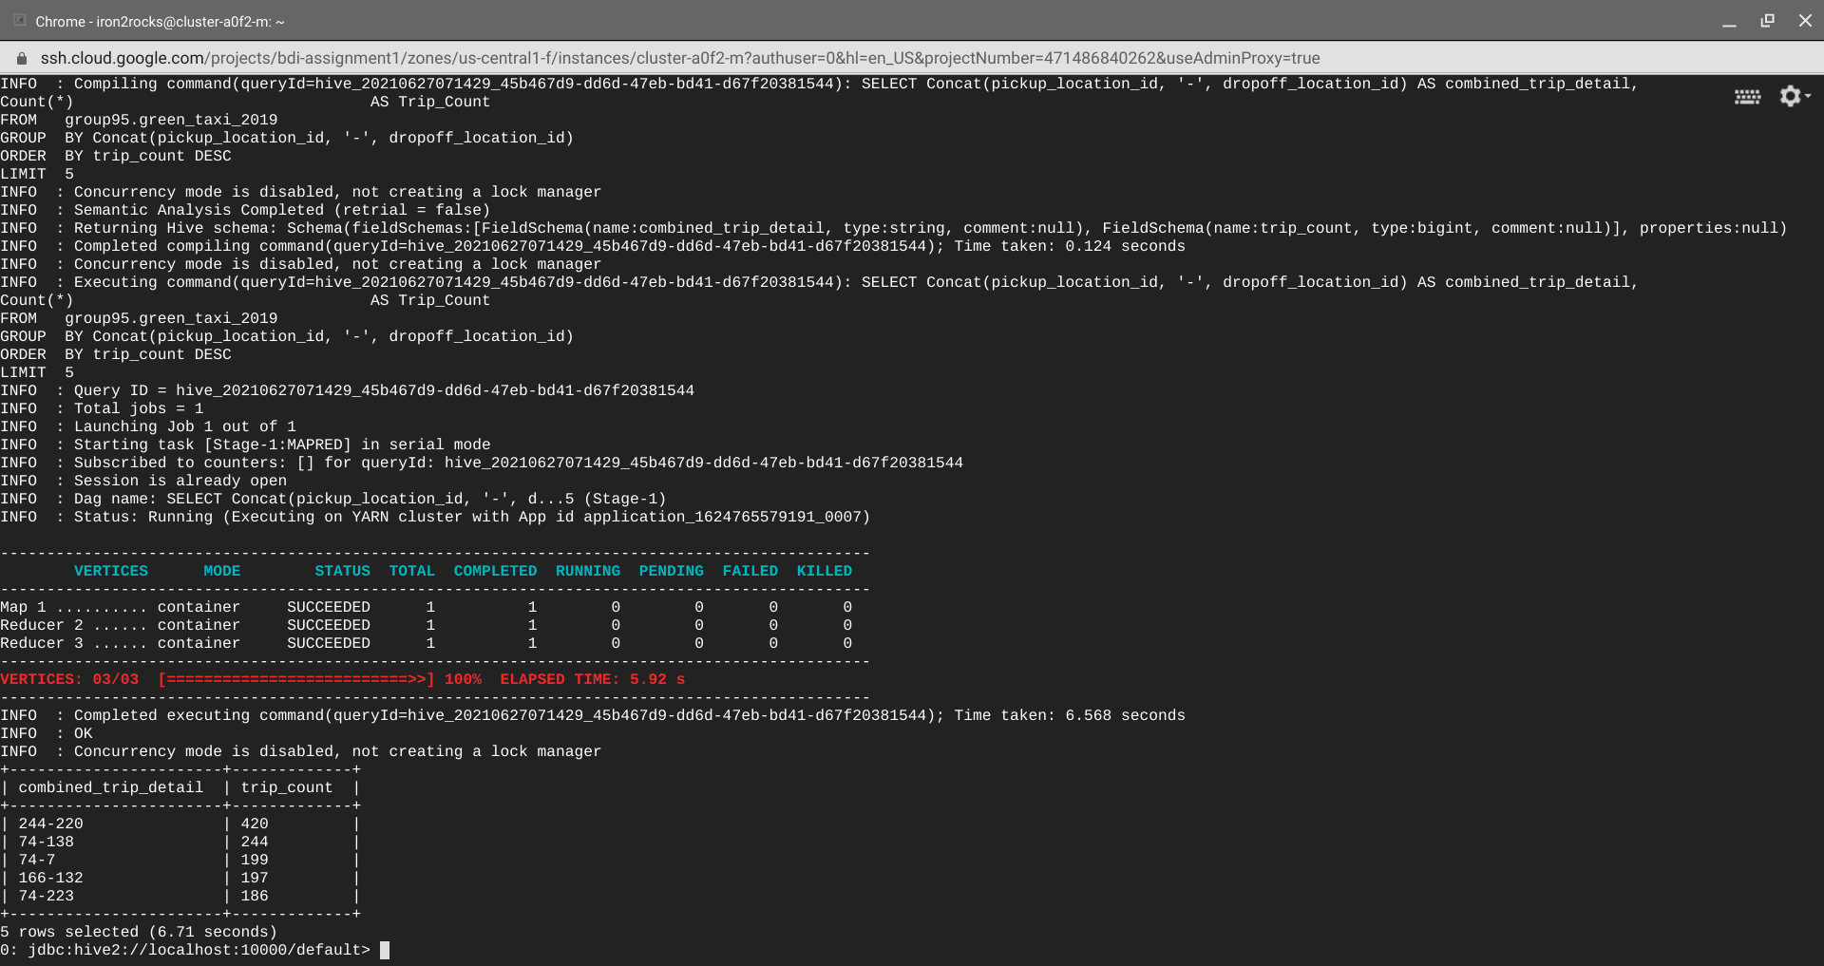

**Output**

**Final Solution**

**The busiest routes of respectives taxis are:**

**Yellow taxi: 132-230, 132-164, 132-170, 132-161, 132-48**

**Green taxi: 244-220, 74-138, 74-7, 166-132, 74-223**

1. **What are the top 3 busiest hours of the day for the taxis?**

SELECT Hour(tpep_pickup_datetime) AS Hour,

Count(*)                   AS Trip_Count  
FROM   group95.yellow_taxi_2019  
GROUP  BY Hour(tpep_pickup_datetime)  
ORDER  BY trip_count DESC

LIMIT 3;

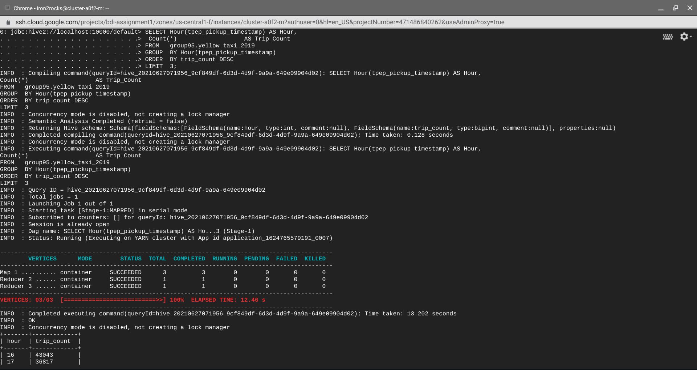

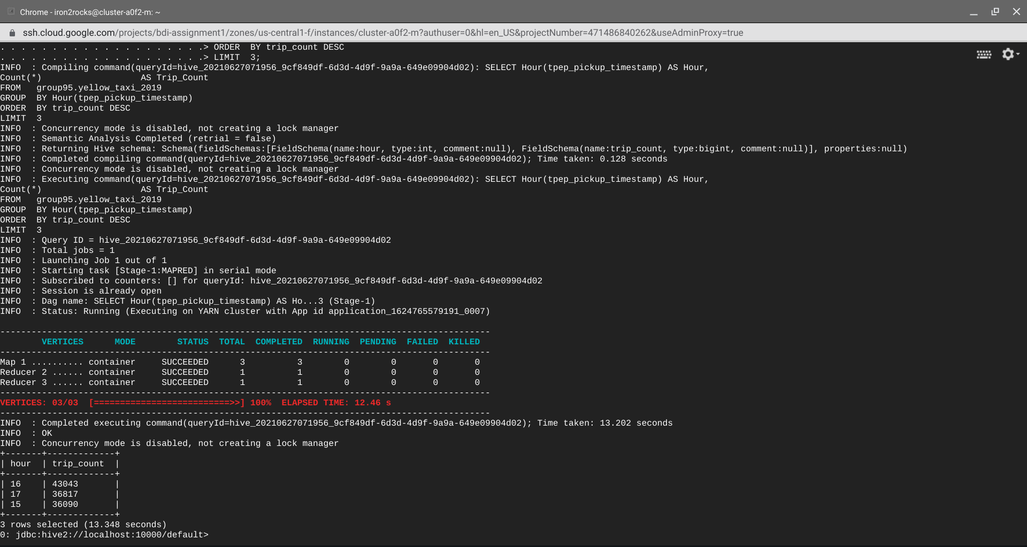

SELECT Hour(lpep_pickup_datetime) AS Hour,

Count(*)                   AS Trip_Count  
FROM   group95.green_taxi_2019  
GROUP  BY Hour(lpep_pickup_datetime)  
ORDER  BY trip_count DESC

LIMIT 3;

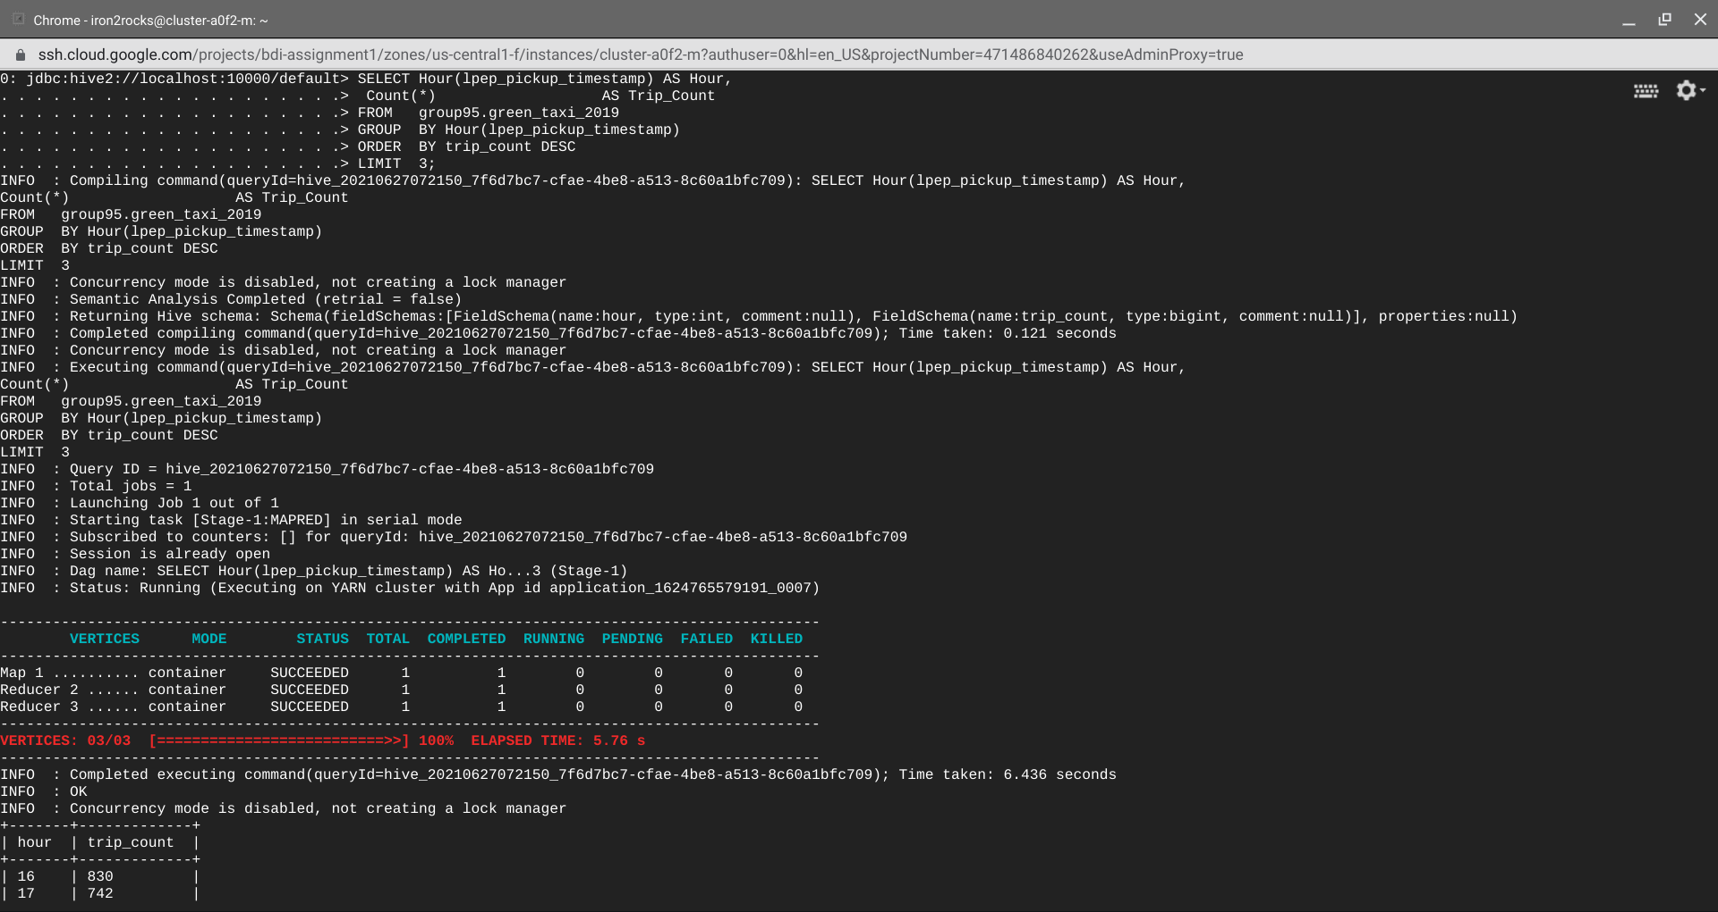

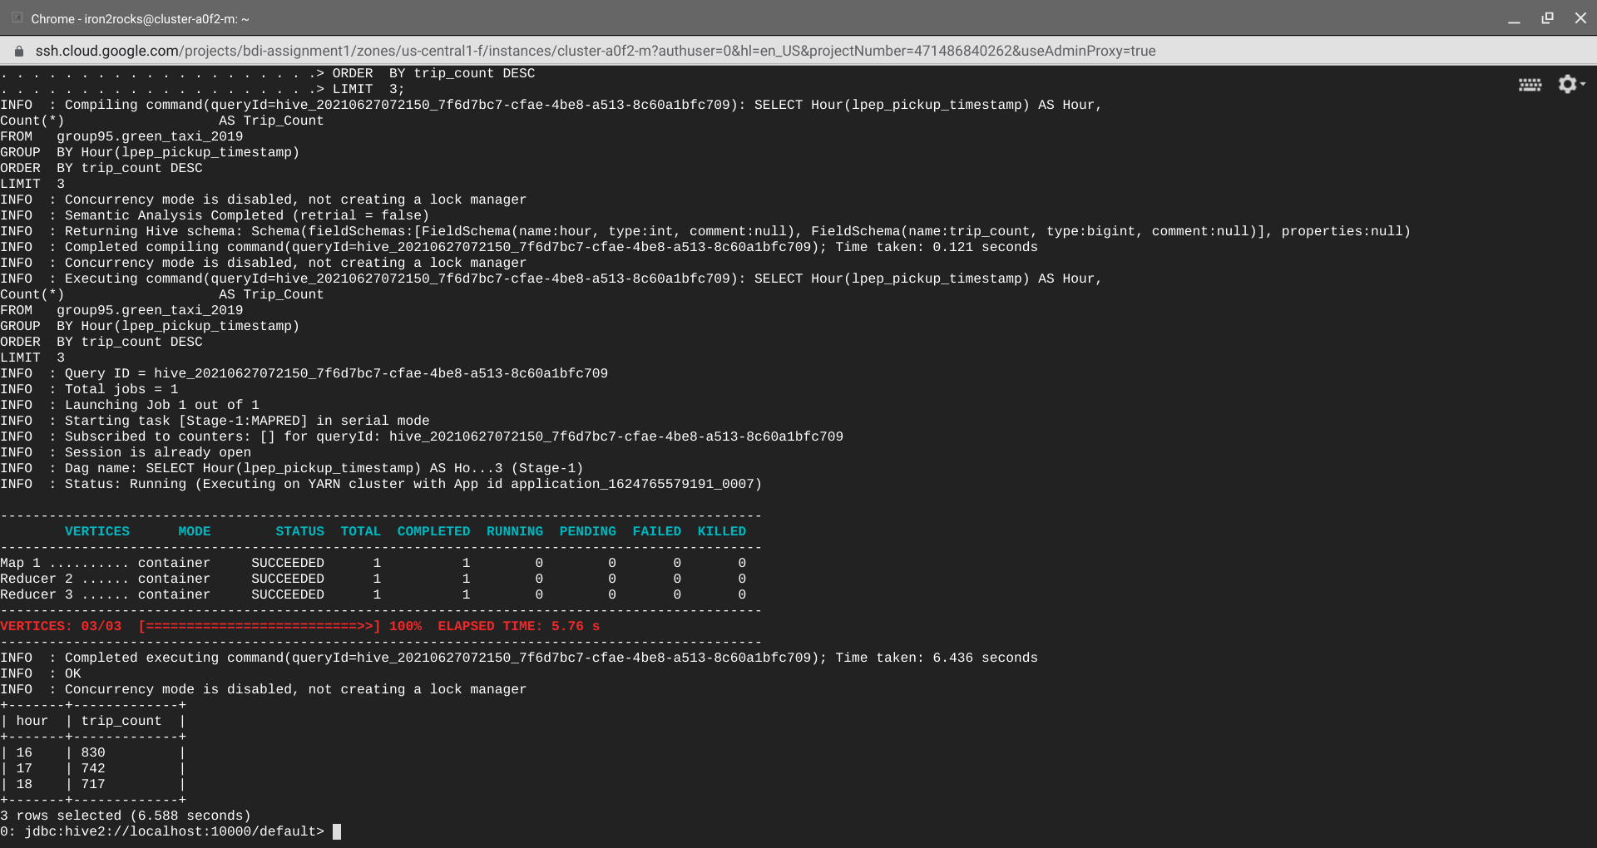

**Output**

**Final solution**

**Respective busiest hours are:**

**Yellow taxi: Busiest hour is 15:00 to 18:00 i.e. 16:00 to 17:00 is highest,17:00 to 18:00 is second highest,15:00 to 16:00 is third highest**

**Green taxi: Busiest hour is 16:00 to 19:00 i.e. 16:00 to 17:00 is highest,17:00 to 18:00 is second highest,18:00 to 19:00 is third highest**

1. **What is the most preferred way of payment used by the passengers? What are**

**the weekly trends observed for the methods of payments?**

**Code part1**

SELECT payment_type AS Payment_type,

Count(*)     AS Record_Count         
FROM   group95.yellow_taxi_2019  
GROUP  BY payment_type  
ORDER  BY record_count DESC;

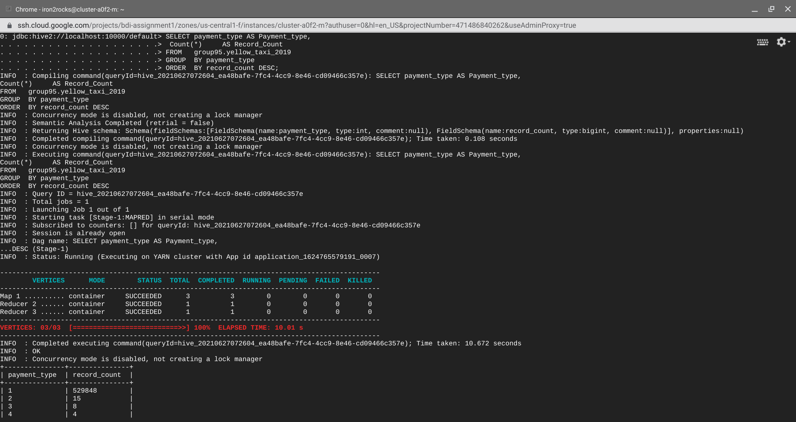

SELECT payment_type AS Payment_type,

Count(*)     AS Record_Count  
FROM   group95.green_taxi_2019  
GROUP  BY payment_type  
ORDER  BY record_count DESC;

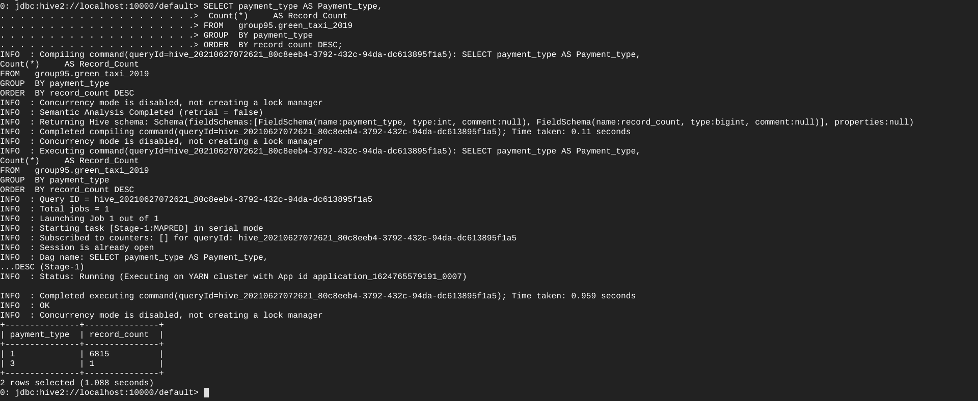

**Output Part 1**

**From the above output and payment_type mapping, Credit Card is the most preferred way of payment used by the passengers for both the taxis.**

**Code part 2**

SELECT From_unixtime(Unix_timestamp(tpep_pickup_datetime), 'EEEE') AS Weekday,  
       payment_type                                           AS Payment_type,  
       Count(*)                                               AS Record_Count  
FROM   group95.yellow_taxi_2019  
GROUP  BY From_unixtime(Unix_timestamp(tpep_pickup_datetime), 'EEEE'),  
          payment_type  
ORDER  BY weekday DESC,  
          record_count DESC;

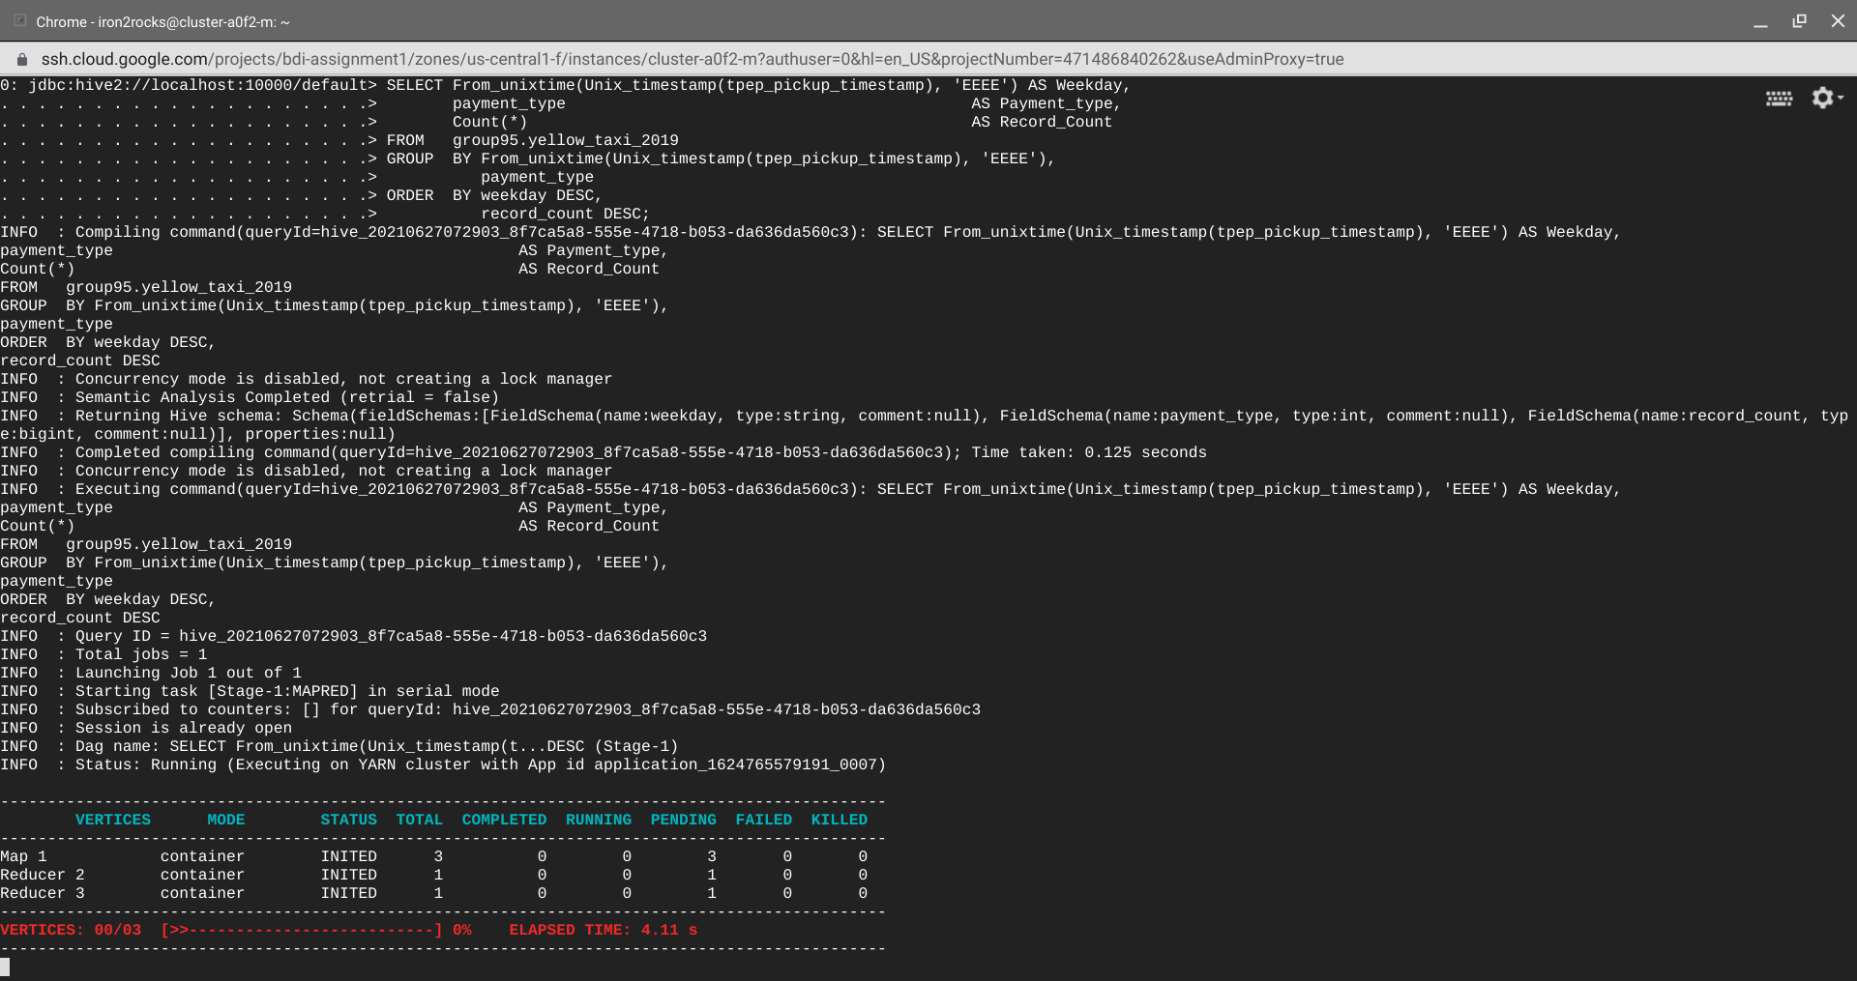

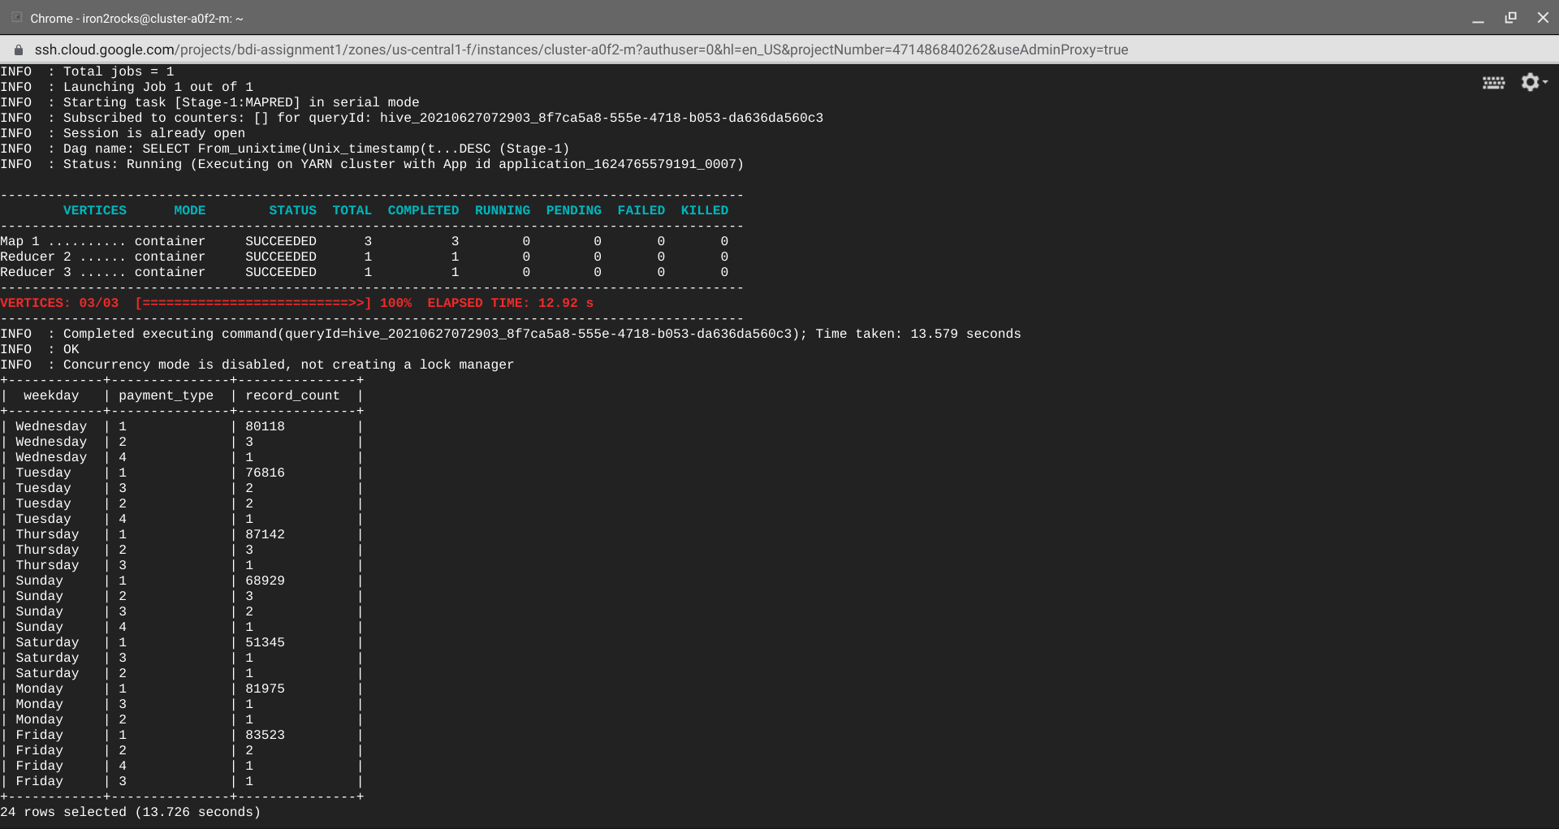

SELECT From_unixtime(Unix_timestamp(lpep_pickup_datetime), 'EEEE') AS Weekday,  
       payment_type                                           AS Payment_type,  
       Count(*)                                               AS Record_Count  
FROM   group95.green_taxi_2019  
GROUP  BY From_unixtime(Unix_timestamp(lpep_pickup_datetime), 'EEEE'),  
          payment_type  
ORDER  BY weekday DESC,  
          record_count DESC;

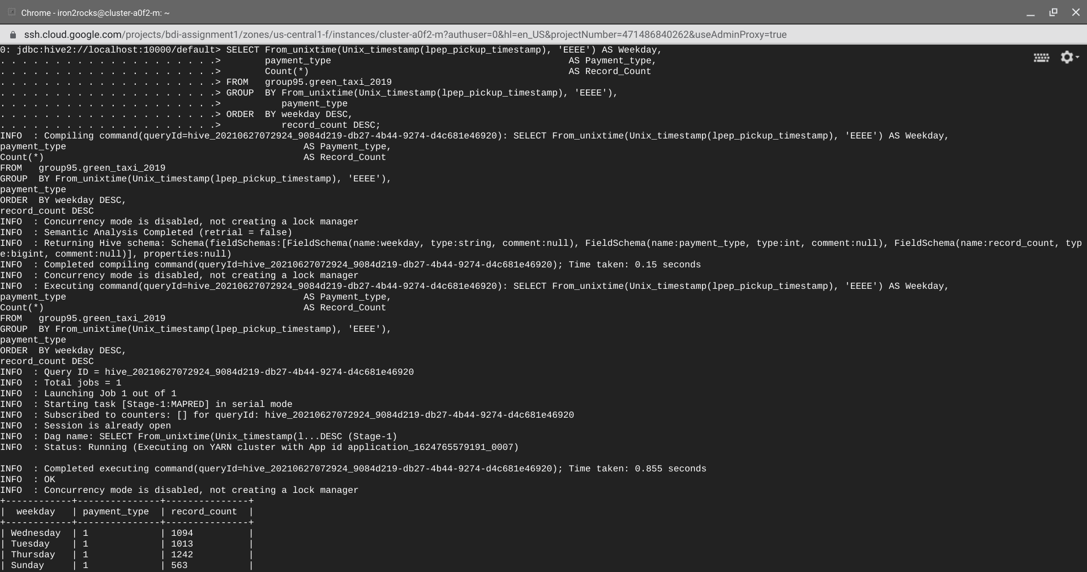

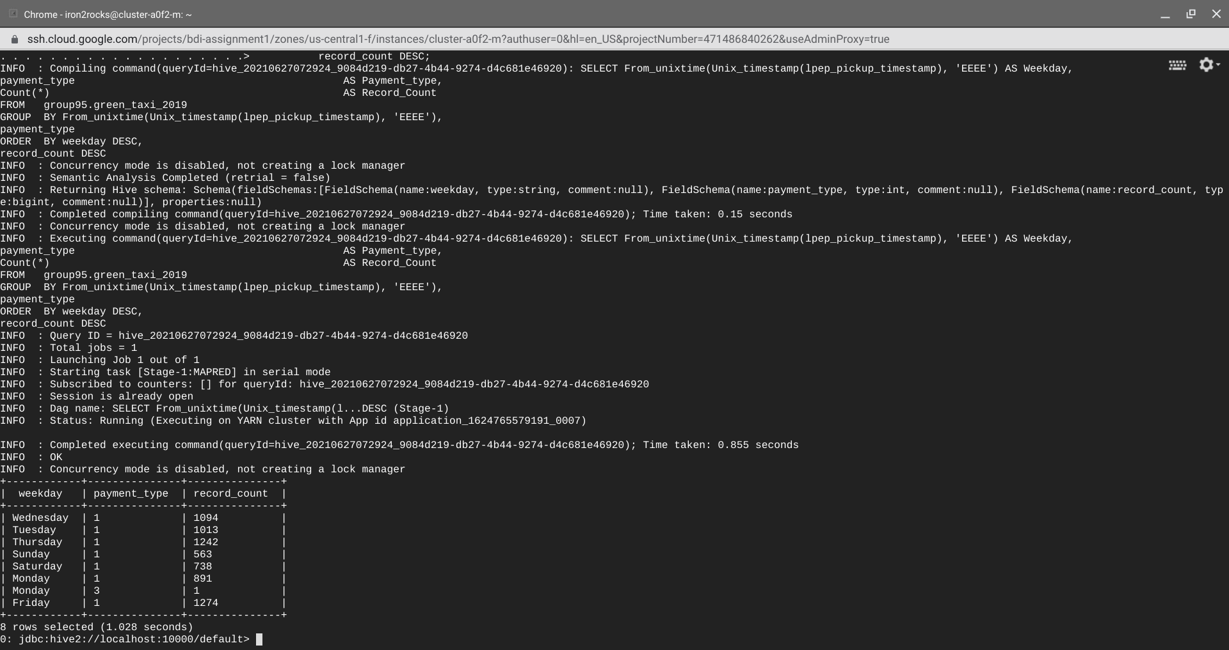

**Output Part 2**

**As we can see from the above outputs, for both Yellow and Green taxis, Wednesday had the overall highest number of payments and Credit card being the most preferred payment method.**

**Visualization:**

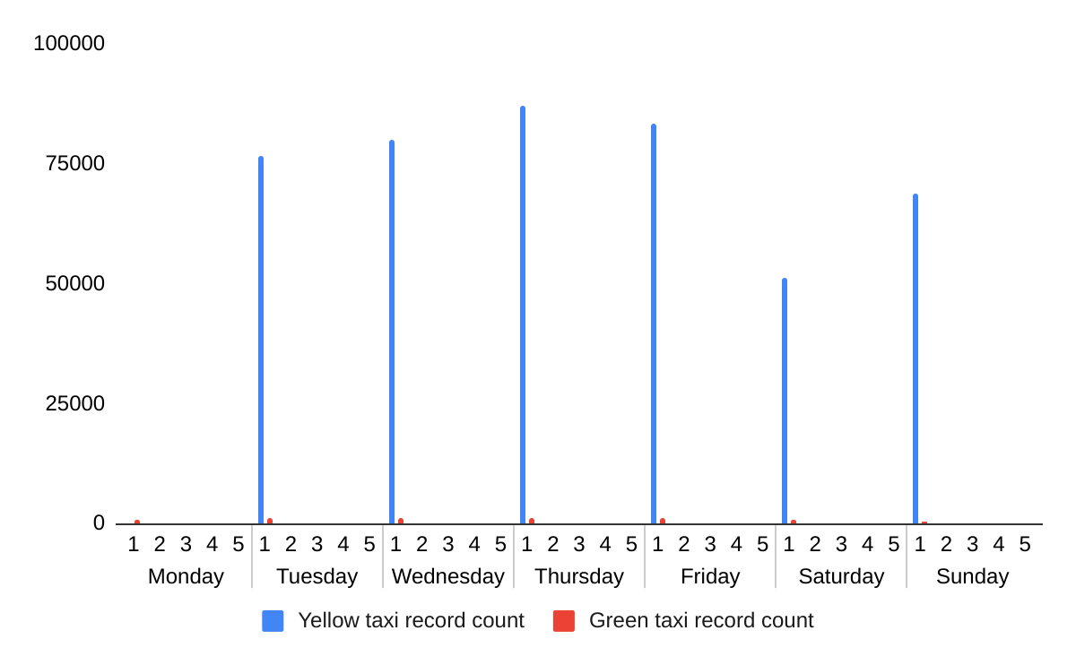

SELECT weekofyear(tpep_pickup_timestamp),

payment_type,

Count(payment_type) AS cnt

FROM group95.yellow_taxi_2019

GROUP BY weekofyear(tpep_pickup_timestamp), payment_type

ORDER BY cnt desc LIMIT 20;

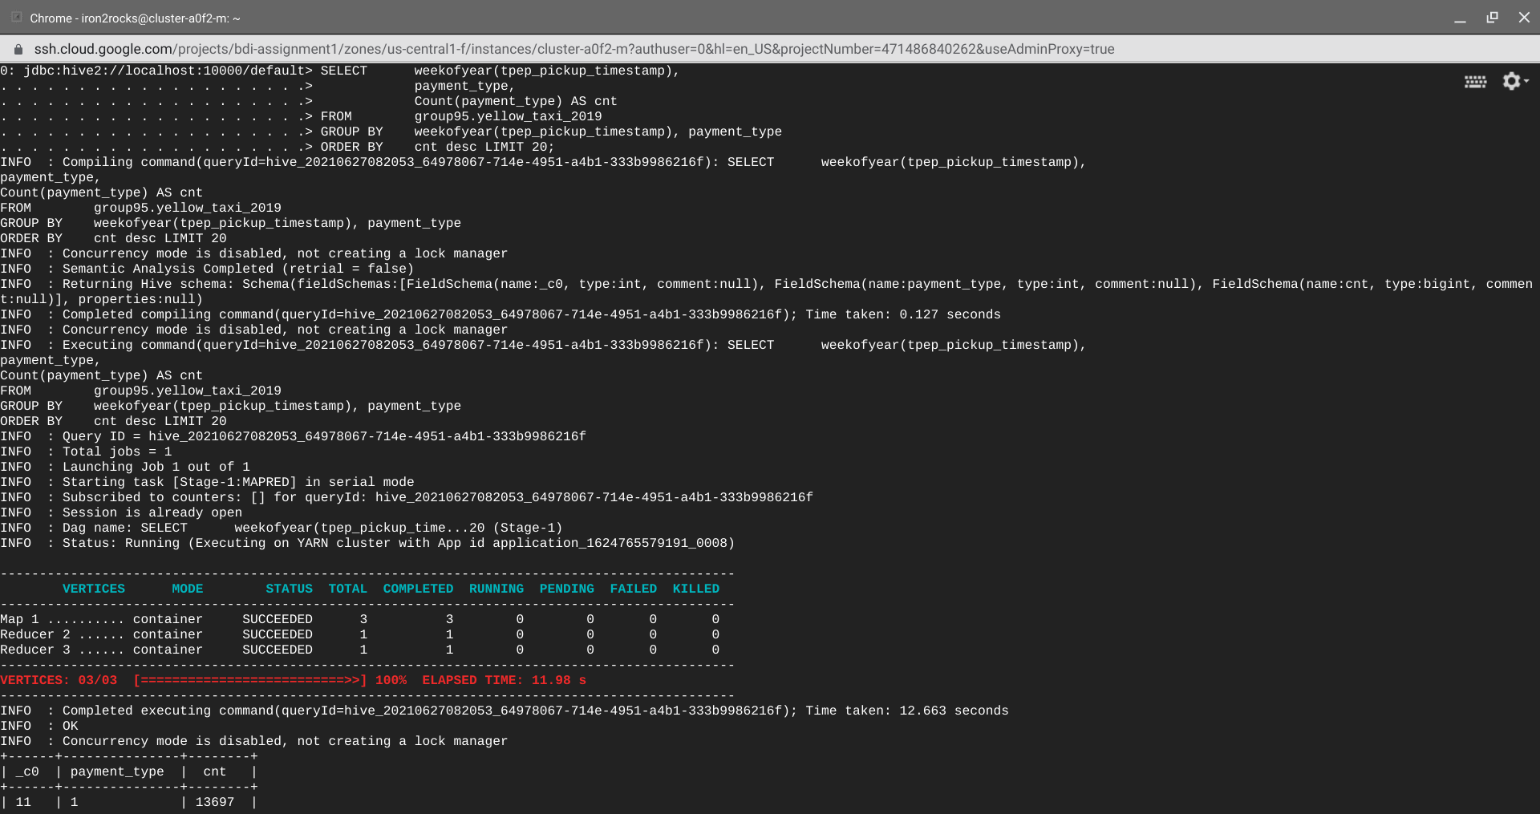

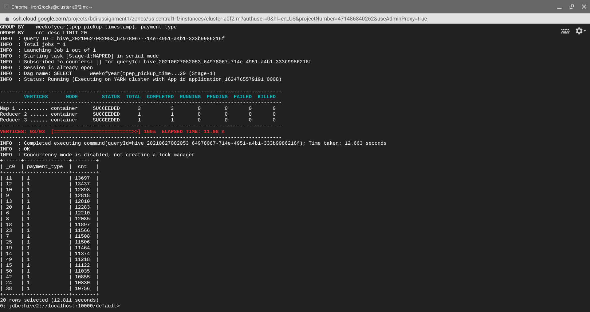

SELECT weekofyear(lpep_pickup_timestamp),

payment_type,

Count(payment_type) AS cnt

FROM group95.green_taxi_2019

GROUP BY weekofyear(lpep_pickup_timestamp), payment_type

ORDER BY cnt desc LIMIT 20;



